Animation in the multimedia centre

Brno elementary school and kindergarten, Jihomoravské náměstí 2, p.o.
Jihomoravské náměstí 2, 627 00 Brno – Slatina
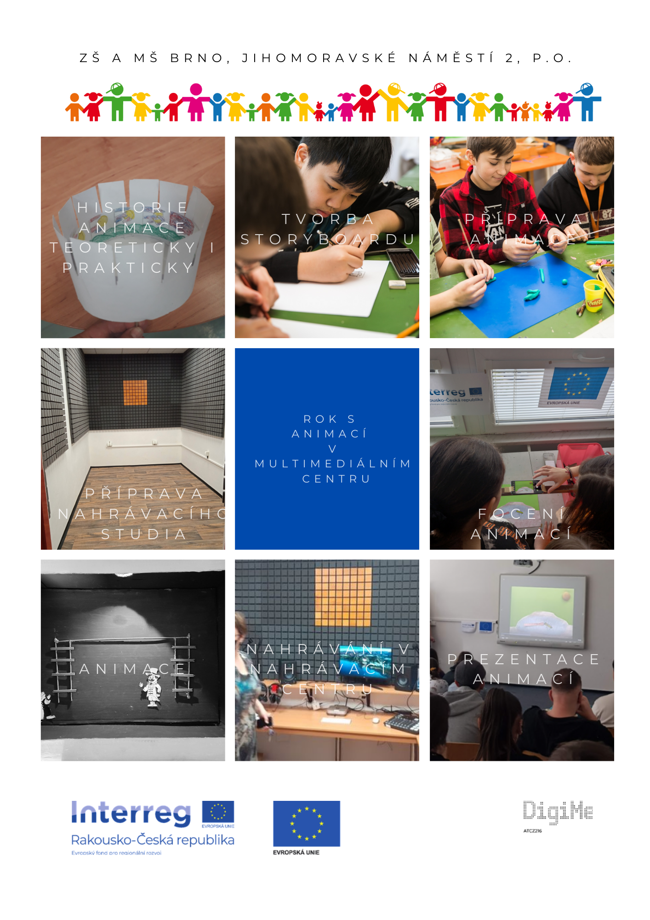
Contents:
Basic information about the project 3
Annotation 3
Project objectives 3
Project information 3
Group structure 3
The benefit of the project for pupils 4
Another possible use of the multimedia centre 4
Theoretical background for the implementation of the project 5
History and development of animation in the world 5
Animation 5
Animation techniques 5
A brief history of animation 6
Making a zoetrope 7
Czech animation 8
Project description 10
Work progress on a short animated film 10
Insert sound into animation 17
Image procedure 18
MacOS environment 19
Software used 19
Sound recording – piano playing 20
Sound recording (speech, noise, singing) 21
Insert sound into animation 22
Project output 24
Preparation of a multimedia centre 25
Printing on a 3D printer 28
Financial complexity of the project 33
Our equipment 35
Evaluation of the project 48
Picture list 49
List of tables 51

Basic information about the project

Annotation
Elementary school Jihomoravská nám. 2 supports pupils' IT literacy in the long term. Computer skills are not the only content of the computer science subject. An interactive whiteboard is available to teachers in every classroom. In addition to two classic computer study rooms, we also have a new mobile computer room. Thanks to it, the possibility of working on computers is expanded as part of regular teaching. We place emphasis on media education. The use of technical possibilities in art teaching and music education is a logical, yet often neglected step.

Project objectives
The project is aimed at supporting interdisciplinary cooperation in art, music education and computer science. Connecting subjects will lead to a deeper acquisition of the necessary skills.

Project information
The acquisition of a multimedia centre will enable students to create high-quality simple 2D animations (flat animation), sound and footage of animations. Classic creative activity with common means of expression will thus be supplemented with a new dimension. In music education, students will make recordings that they will process in computer science (video editing, sound and video mastering, noise removal), they will have the option of recording their own words.
Practical activities will significantly expand students' IT and media competences. Work in the implementation team will lead to the development of soft skills in students - team formation, the importance of different age and social groups for the enrichment of the team, communication and cooperation in the team; setting goals, timelines, and delegating tasks and responsibilities; factors affecting teamwork, etc. pupils will be able to realise themselves, their innovative thinking will develop.
The short animated films created by the students will be presented on the school website and as part of the school festival.

Group structure
The project is intended for pupils of the second grade of primary school. 6th and 7th grade students aged 12-14 worked on the project. The project was very challenging for the 6th graders. It seems far more suitable for 7th graders who are already familiar with basic office applications. The project is quite demanding on the organisation of teaching and the self-discipline of pupils. From a technical point of view, a path was chosen that would allow students to experience success in the implementation process.
In order to master basic animation, students need to have basic skills in PowerPoint and be able to process photos.

The benefit of the project for pupils
Pupils will master the ability to create simple 2D animations, sound effects and footage of animations. They will learn to create backgrounds for animations and individual figures, make recordings that they can process within computer science (video editing, audio and video mastering, noise removal). They will develop teamwork skills. Collaboration will be key to the success of the project. The development of presentation skills and the presentation of the created work at the final competition seem very beneficial to us.

Another possible use of the multimedia centre
- Creating simple animations
- Sound and footage of animations, videos
- Basic and more complex video editing
- Recording processing (video editing, audio and video mastering, noise removal)
- Recordings of own words, editing
- Presentation video elementary school
- Shapes of tones, colour of music, play with virtual instruments, composition of simple music recordings
- Visual and musical connection, multiple songs in one
- Options for editing recordings of school polls, connecting animation spots
- More complex editing and creation of logos, animations

Theoretical background for the implementation of the project

History and development of animation in the world
For a deeper understanding of the principles of animation in the past and to understand the historical context, it was necessary to familiarise the students with the history and development of animation. In order to understand the principle of animation, the pupils tried to divide the movements of their classmates while they were running. They then created a paper zoetrope to understand historical ways of recording movement.

Animation
The word animation comes from the latin word anima (soul), so animation literally means animating, reviving, breathing life. The principle of animation is the recording of consecutive sequences of images, each static in itself and slightly different from each other. When these images are displayed quickly, thanks to the inertia of the human eye, the impression of smooth movement is created. The images, however, must play at such a speed that the eye no longer perceives it.
Animation is a broad term that includes all possible approaches to animating an image.

Animation techniques
Animation techniques can be divided into 3D and 2D. Among 2D we include, for example, classic cartoons (i.e. cartoon animation for pauses on needles and transilluminator) or digital cartoon animation using a graphics tablet, as well as under-camera (or flat animation), rotoscopy, etc. We can include the stop motion technique (so-called windowed animation) in the 3D category. , puppet animation, pixilation, clay animation, semi-plastic animation and finally also computer animation created in 3D animation software.

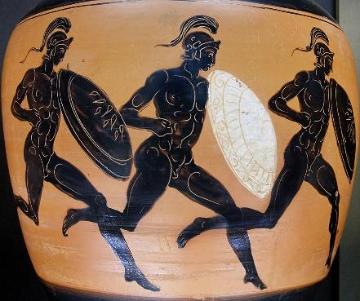
A brief history of animation
Obrázek – bratři Lumierové - příjezd vlaku
14,000 BC Altamira The first attempts to depict the movement of animals on the walls of the cave
2000 BC Egyptian wall paintings - An Egyptian wall painting in the tomb of Baqt at Beni Hasan, depicting the stages of a struggle between two polychrome figures.
1600 BC Temple of the Goddess Eset – Ramses II had the 110 columns of this temple painted with the phases of movement of the goddess Eset. Passing chariots could watch the animated dancing goddess.
Picture – Heavyweights running on a Greek amphora
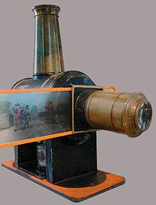
400 BC Greek pottery Amphora depicting heavy-footed men running.
1640 - invention of Laterna magic - Athanasius Kircher, Christiaan Huygens - this is a device that enables the projection of images.
A significant turning point occurs - the display ceases to serve only religious worship, it begins to exist for the mere entertainment of the viewer.
19th century - discovery of the fading effect of visual perception - Thaumatrope
1867 - zoetrope – William Lincoln invented a device that, with its special design, made it possible to revive a strip of individual drawings in a continuous moving image. Students can easily make this device.
1877 - Praxinoscope – Charles-Émile Reynaud
1882 - Camera rifle – Thomas Etienne-Jules Marey – a tool that allows you to take a sequence of shots in a short time, and to create studies of the movement of people and animals.
1892 - Charles-Émile Reynaud Optical Theatre – praxinoscope + slide projector
1889 -invention of the motion picture camera – Thomas Alva Edison
1895 - the first film: the Lumiere brothers – the arrival of the train
Discovery of the film trick and stop-motion animation by George Meliés (A Trip to the Moon, 1902)
1906 - the first animated film – uses several animation techniques (Humorous phases of funny faces)
1909 - ITALIAN FUTURISTS Fascination with movement, speed and volume of the modern age. Giacomo Balla
1919 - Felix the cat: The first animated movie star (Creators: Pat Sullivan and Otto Messmer)
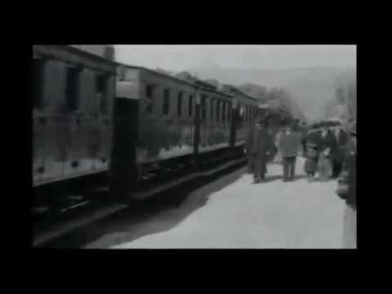
1923 - founding of the Walt Disney Company (Original name Disney Brothers Studio)
Alice in Cartoonland (1924)
Silly Symphonies: The Skeleton Dance (1929)
1928 - Mickey Mouse Mickey Mouse – Episode 1: Plane Crazy (1928) Mickey Mouse – Steamboat Willie (1928) music and movements synchronised with image for the first time
Silly Symphony: Flowers and Trees (1932) - first colour film Snow White and the Seven Dwarfs (1937)
Alice in Wonderland (1951)

Making a zoetrope
In order to understand how animation developed, the students decided to make a zoetrope. It is one of several pre-film animation devices that create the illusion of motion by displaying a sequence of drawings or photographs showing the progressive stages of that motion. It was essentially a cylindrical variant of the phénakisticope.
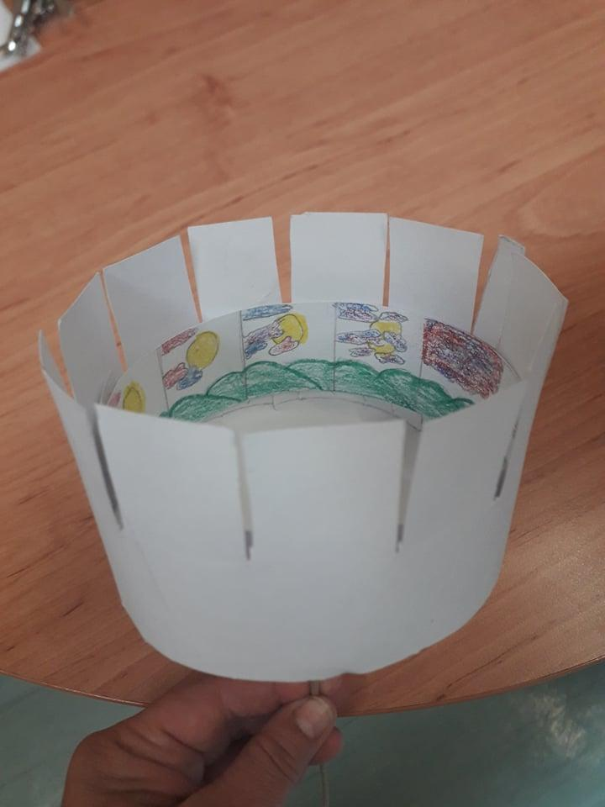
Pupils will make a zoetrope according to the following template, which they will glue together and complete the pictures. Using a stick stuck in the centre of the circular base and secured with a melt gun, they can spin the zoetrope.
Obrázek – Zoetrope vyrobený žáky
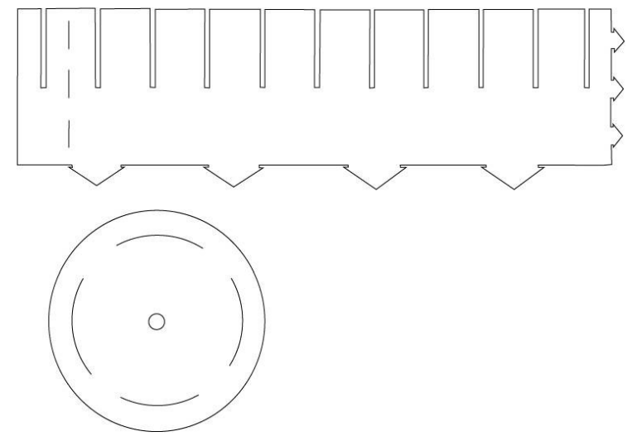
Picture 5 - Template for making a zoetrope

Czech animation
Czech animated film has its origins after the Second World War. The classics of Czech animation include, for example, Jiří Trnka, Karel Zeman, Hermína Týrlová, Břetislav Pojar, Jiří Brdečka, Eduard Hofman and many others. At that time, animated films were produced in Zlín and Prague. Two leading studios functioned in Prague: 1945 Bratři v triku studio founded (with a focus on cartoons) 1947 Jiří Trnka founded the Puppet Film Studio. Another centre of animated film was Zlín, where, for example, Karel Zeman or Hermína Týrlová filmed. Czech animated film was at the world level at that time. Animals and Pets (1946) This film won the main prize at the Cannes Film Festival in 1946. Hermína Týrlová was called the so-called Disney of the East. Recent examples include the animators Aurel Klimt Fimfárum (2002) and Filip Pošivač Up to the ears in moss (2015) 3.
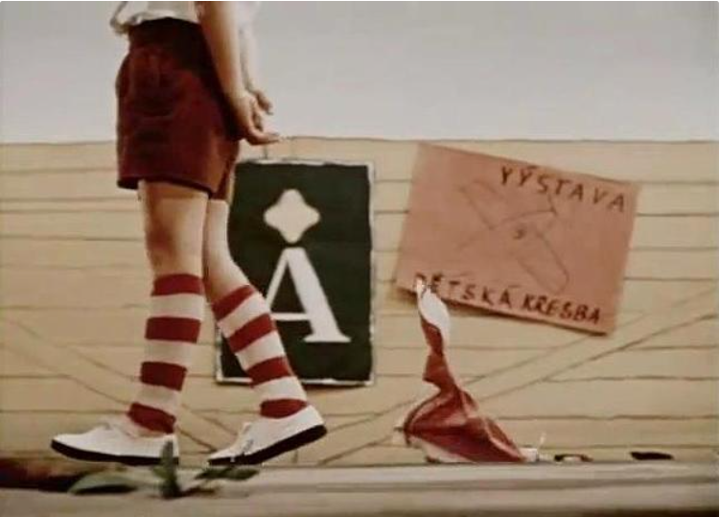
Picture 6 - Stills from the animated short Knot in a Handkerchief (1958)
The most interesting short animated film that the pupils watched was The Knot on a Handkerchief (1958) by the Czech animator Hermína Týrlová. .

Project description

Work progress on a short animated film
1. Pupils come up with a topic and make a basic plan - sketches, proposals, notes.
2. This is followed by the preparation of the scenario and the realisation of the storyboard.
The script of the animated film connects several teaching subjects. The basis can be work in literature to search for a literary model, work with text, style exercises. It is also possible to use natural history, geography, history, physics, chemistry, etc.
Once we have an idea ready and created a literary template, it's time to draft the storyboard. It is an equally essential part of the preparation for shooting an animated film. we will lay out the script scene by scene, they will state the technical details, or the dialogue or commentary that will accompany the picture.
Students record individual scenes in a "storyboard" using pictures and labels.
Picture 7 – Storyboard
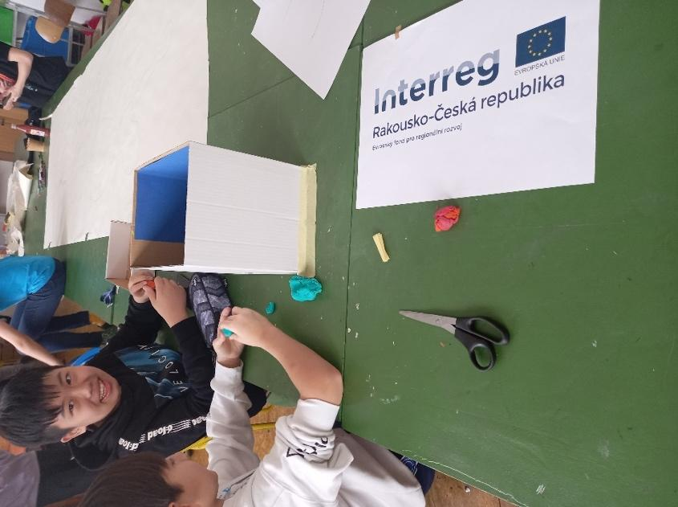
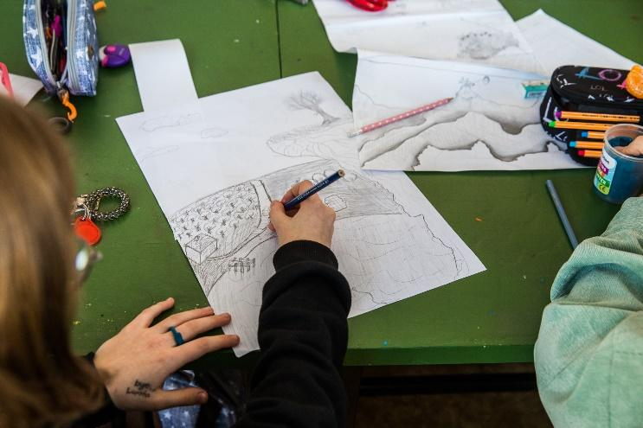
3. Based on the storyboard, together with the teacher, they clarify what they will need for the animation and then prepare the necessary props and backdrops, invent the environment where the film will take place.
Obrázek - Výroba pozadí a rekvizit

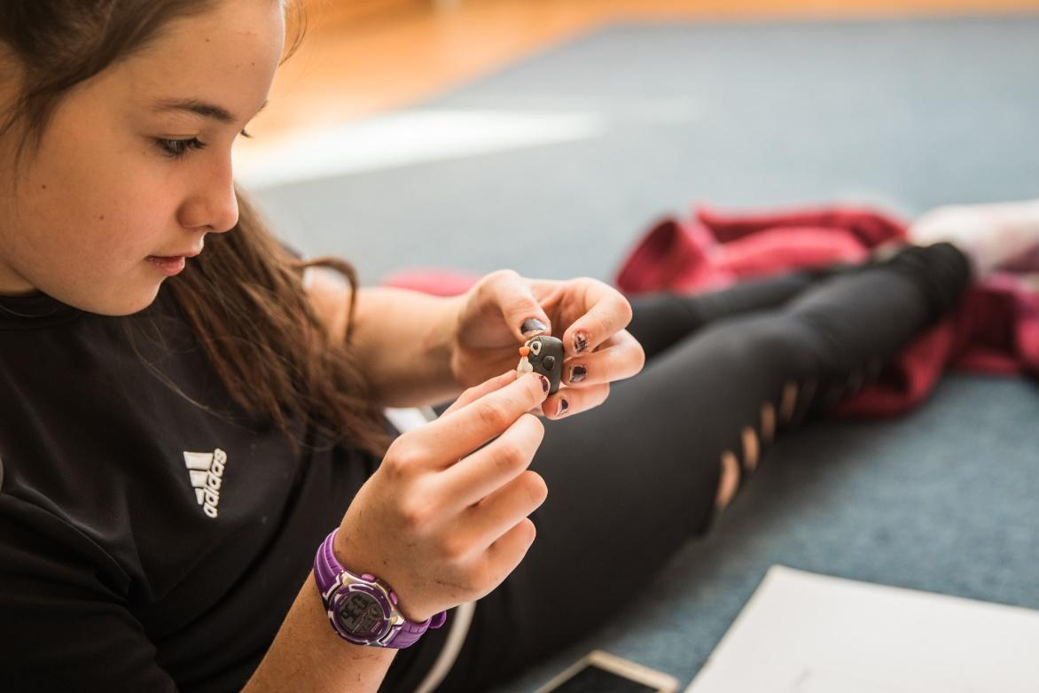
Obrázek – Výroba pozadí a rekvizit
Obrázek - Výroba pozadí a rekvizit
4. Lighting needs to be resolved. It is possible to shoot in daylight as long as it is not too choppy. It may be that it causes a problem during exposure. In that case, it is more appropriate to use artificial lighting. An ordinary lamp is enough for this.
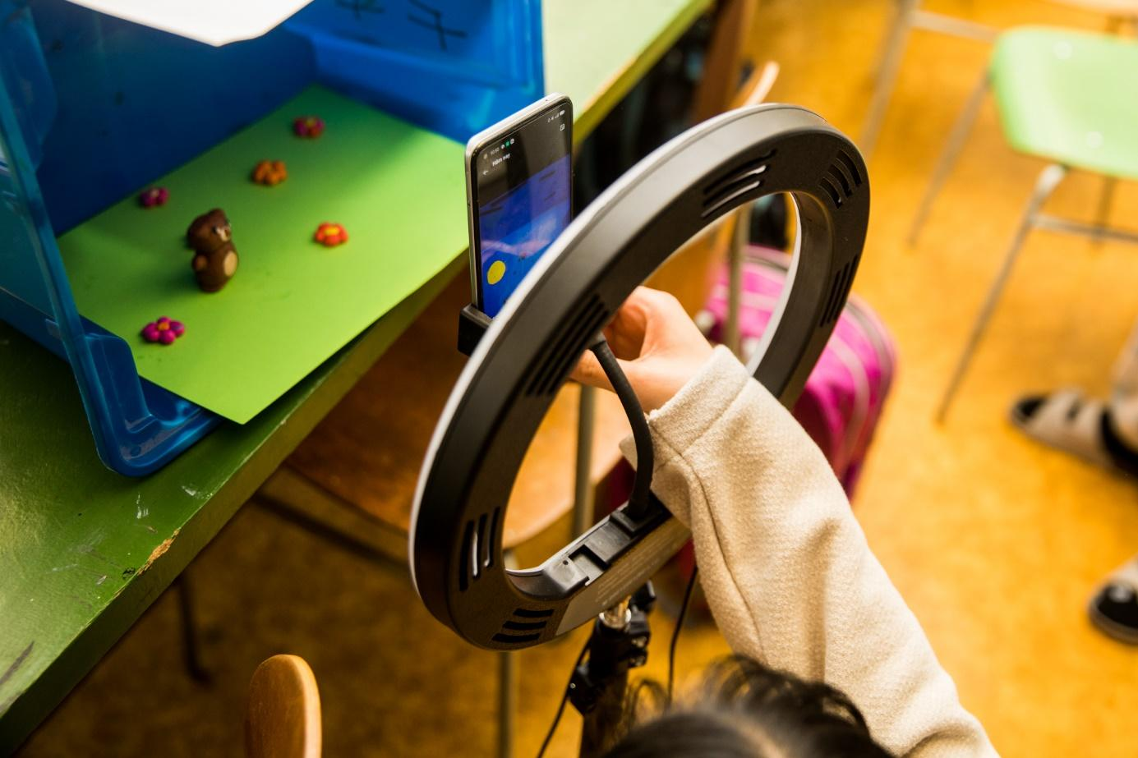
Picture 11 - Lightining
5. Next is the choice of photographic equipment. For the first tests and familiarisation with the principles of animation, the use of ordinary mobile cameras is sufficient. Pupils move the animated objects and take pictures. Once they have mastered the activity sufficiently, they can try an LED panel for better lighting of the scene, a professional camera, the use of a tripod, or a stabiliser (so-called gymball) for less shaky and stable gradual photos while moving.
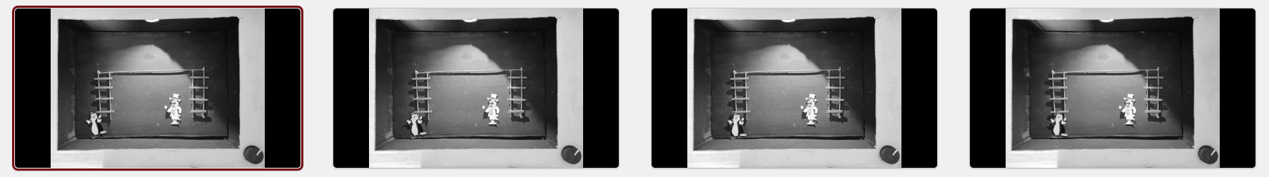
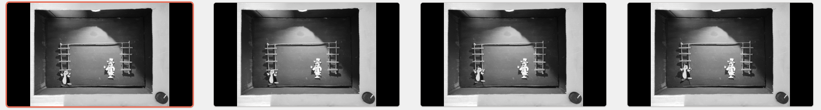
Picture 12 – Photography of movement
6. For school conditions, a simple alternative for animation processing is the use of the MS PowerPoint program. It is a familiar environment for students, which enables basic work similar to work in animation programs, it is free. We insert photos into MS PowerPoint as a photo album.

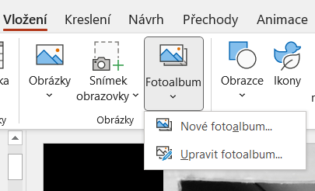
Picture 13 – Creating a photo album in PowerPoint

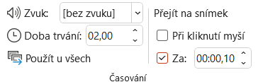
The application allows the use of frames per sec settings, i.e. setting the number of frames per second. The principle of animation is the basis for film. The human eye has a certain inertia, i.e. the image remains recorded on the retina for a certain period of time. Thanks to this, it is possible to create the illusion of continuous movement by means of rapidly alternating images. Film typically uses 24 frames per second and is shot with a real-time camera. Classic animation uses a standard speed of 12 frames per second, recorded by a camera,
and so this process is very lengthy compared to filming. The higher the frame rate, the smoother the movement.
Picture 14 - Timing

7. Export animation from the presentation – PowerPoint allows export in mp4 format.

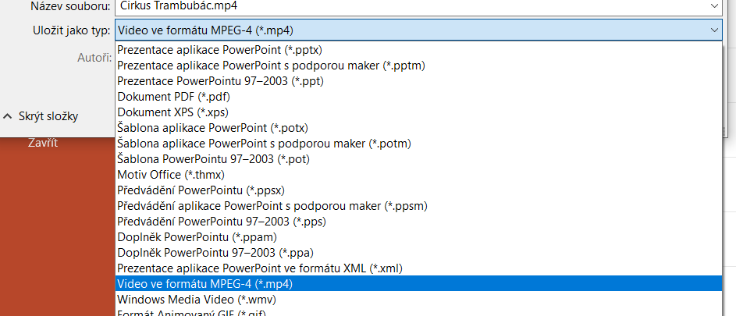
Picture 15 - Export to mp4
In the Animations tab, it is possible to open a window and further edit the animations as needed.

Picture 16 – Editing animations
8. post-production – after obtaining the animation from the PowerPoint program, exporting the video to mp4 format, we can gradually add sounds to the animation. Pupils themselves choose, think about what would fit into the given animation. One group created various noises, spoken word, others used only piano versions of well-known compositions. This piano version was recorded by a sixth grader who plays the piano.
We recorded the sound via the RodeCoster Pro mixing desk and the GarageBand program, where you can set various options, filters, or post-editing.
After recording the sounds, songs, noise, the last part is processed in the iMovie program, where after creating the project, the exported animation is inserted on one track, the other tracks are for inserting our recorded sounds, their subsequent shortening, editing, transition. Different transitions can also be inserted between individual animations. The program also makes extensive use of the options of subtitles, of various types and types.
The step-by-step steps, including previews of our progress, are in the following chapter
9. export the resulting animation including the recorded and inserted sound in the iMovie program.

Insert sound into animation
Before the actual post-production of the student animations that the students had created, it was necessary to prepare the entire multimedia studio. The complete preparation of the centre consists of unpacking, thinking about and placing the individual components, then connecting them to the electricity, testing them, and connecting the individual equipment. Step-by-step installation steps:
- Unpacking, preparation, connection of individual parts, testing
- Connecting all devices with each other
- Installing and activating the computer and audio mixer
- Connection of other possible peripherals
- Verification and possible installation of software supported and freely available for MacOS – GarageBand, iMovie, Keynote
- Testing the ability to record sound, record sound from an electronic piano, correct input and output settings
- Recording of the spoken word, various movements, playing piano pieces
We deliberately chose a computer with the macOS operating system for several reasons. Their relatively longer lifespan of the operating system, its support, current performance even after updates. Another reason was the freely available basic programs for recording various sounds, editing and video editing. From these programs it is also easy to switch to the paid ones, their operation is very similar.
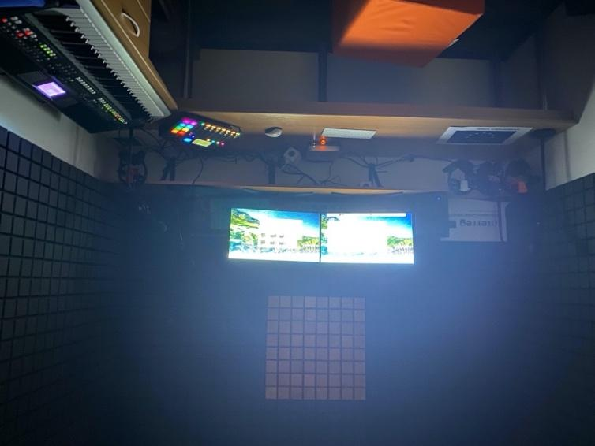
Of course, the testing and complete connection did not avoid small complications, from the minor ones in the form of a short cord, not enough USB ports for connecting all the planned peripherals, through inappropriate extension cables, splitters, etc., to the impossibility of connecting all parts of the multimedia centre together. Gradually you connect everything, and the necessary accessories. We had to deal with the most settings for the RodeCoaster mixer, the inputs for the microphones and also, above all, the functionality with the computer, the correct connection of the piano, which we had unused at school. The piano has various input settings, sound output and options as a stand-alone instrument without connecting to a PC. Here we set everything up so that the sound comes out of the PC speakers when connected to GarageBand and all its effect settings. We overcame all these troubles and were able to start recording sounds, noise, playing the piano etc., which we then incorporated into the resulting animations.
Obrázek - Postprodukce
As they say, there are no limits to imagination, which is why we were only an advisory voice for the animations of individual groups of pupils. We used the GarageBand program to record various types of sounds, possibly multiple sounds at once, be it a voice, noise, playing the piano, etc. After recording the sounds, we inserted the given animation as a video into the iMovie program, added the recorded sound to it, we used different subtitles, opening and closing pages, possible adjustment of the length of the sound, its correct and appropriate incorporation into the resulting animation. If necessary, we returned to the GarageBand program and adjusted the outputs, various shortening or stretching of the sound, and export to mp3 format.

Image procedure
Screen recording of the so-called print screen during successive activities and recording of sounds, inserting them into animations, subsequent export and then the resulting video – animation with sound. The print screen on computers with the macOS operating system is different than on Windows. Just as on Windows, you can start from the classic recording of the entire screen (Shift + Command + 3), so you can also only a certain part of the selected window (Shift + Command + 4), or the option of displaying the print screen options (Shift + Command + 5).

MacOS environment
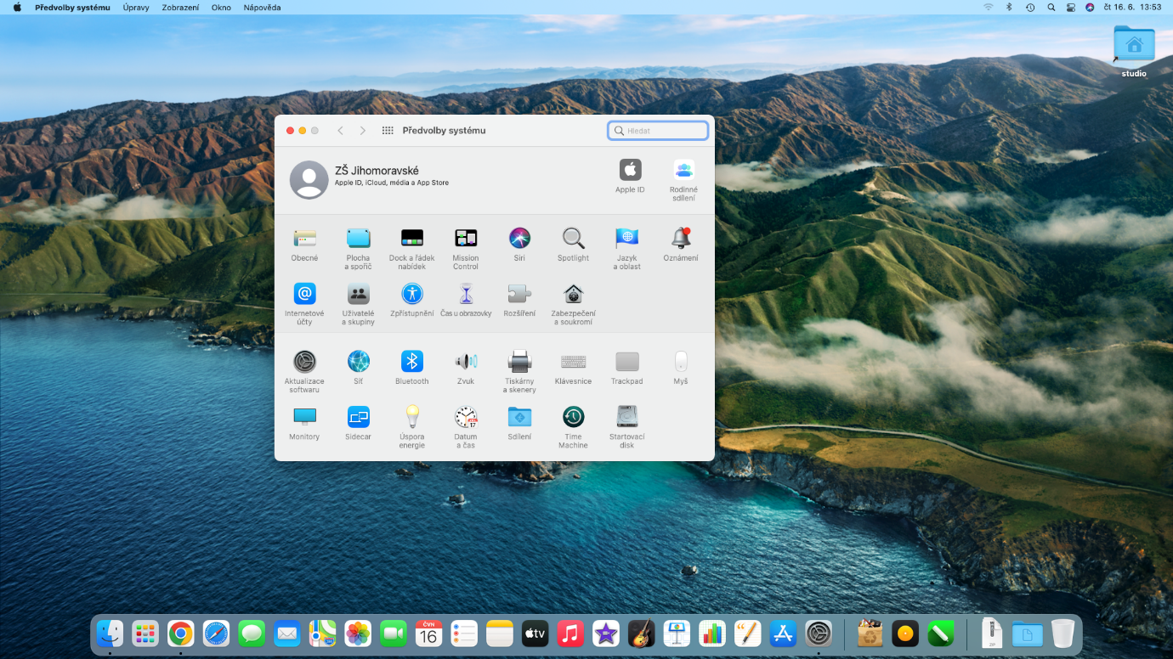
Picture 18 - macOS, an operating system from the Apple brand

Software used
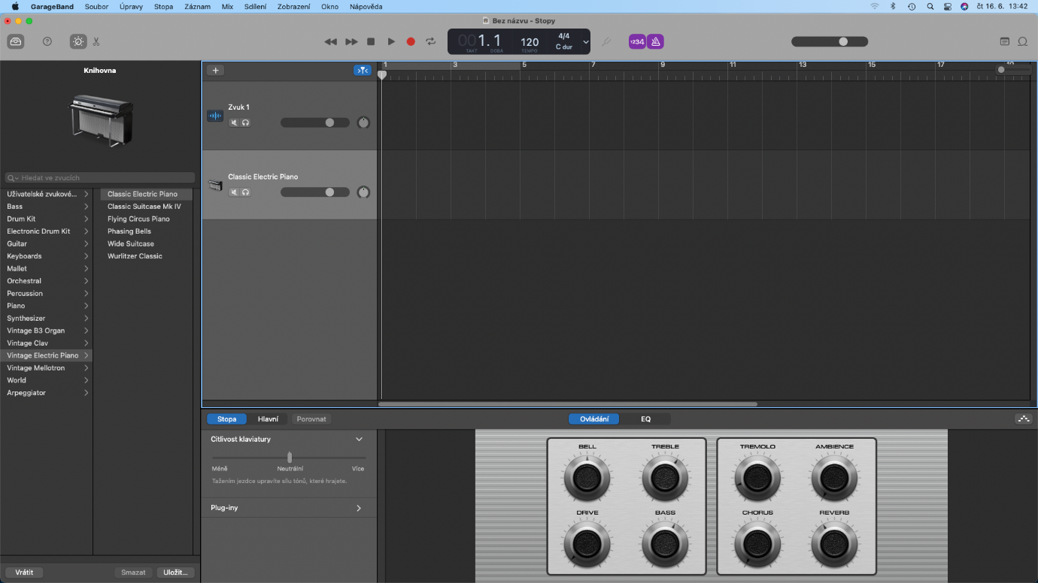
Picture 19 - GarageBand
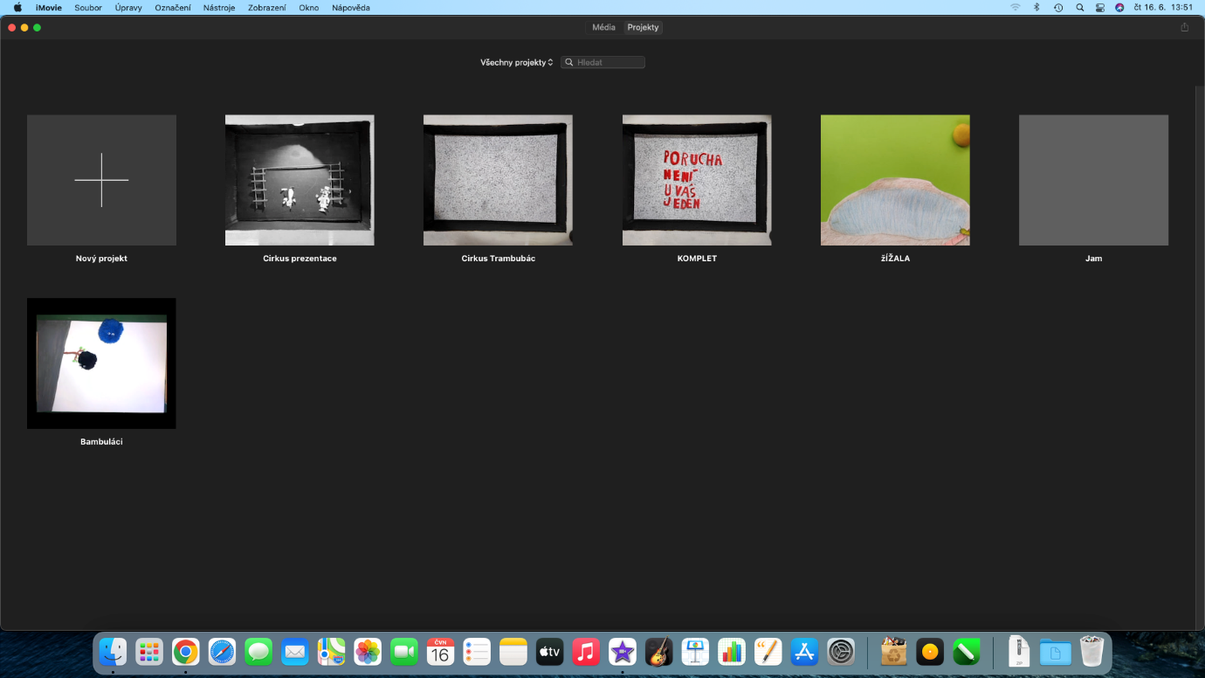
Picture 20 - iMovie (editing, editing, video editing)

Sound recording – piano playing
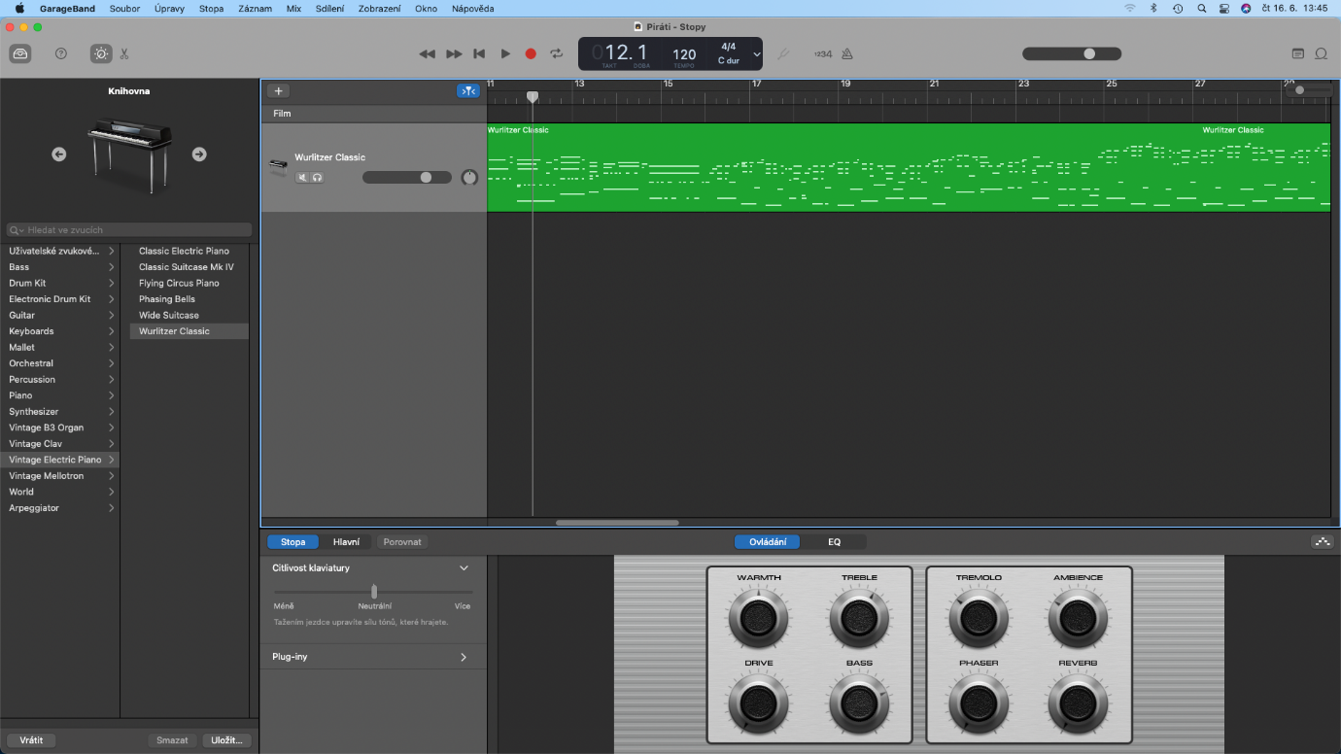
Picture 21 - GarageBand environment when recording piano sound

Sound recording (speech, noise, singing)
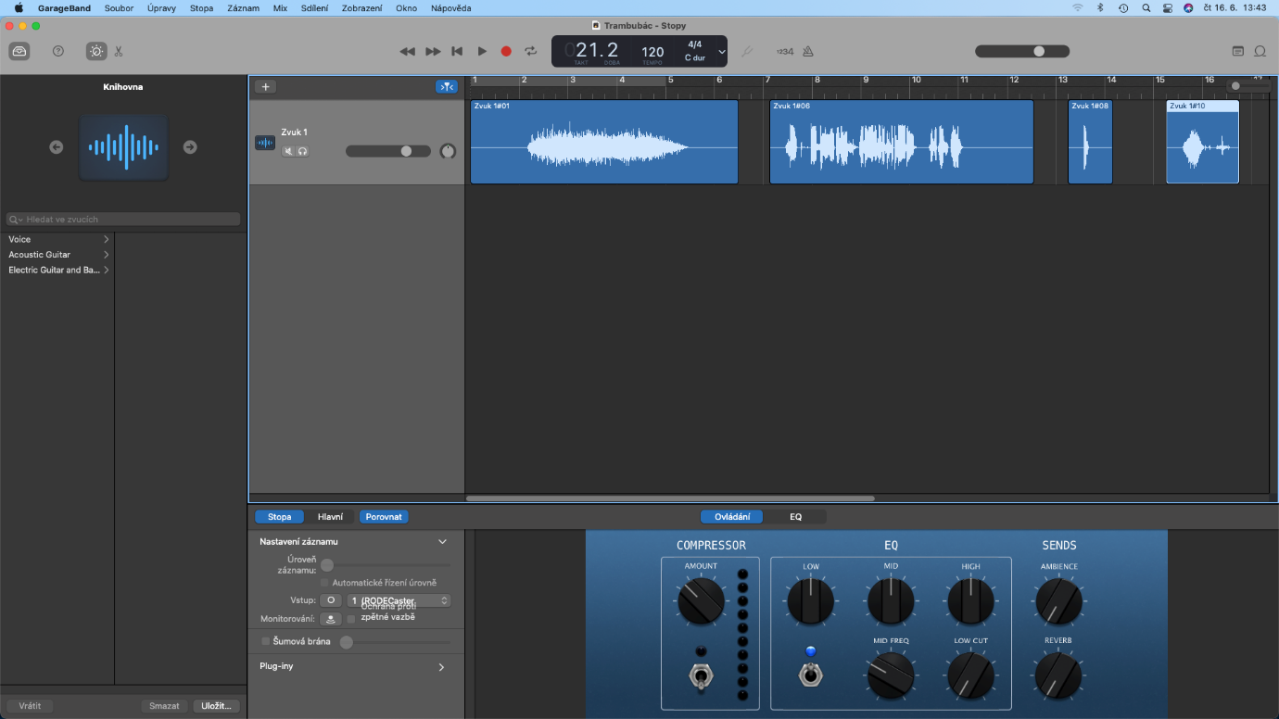
Picture 22 –Recording different types of sound into an animation (spoken word, falling, noise)
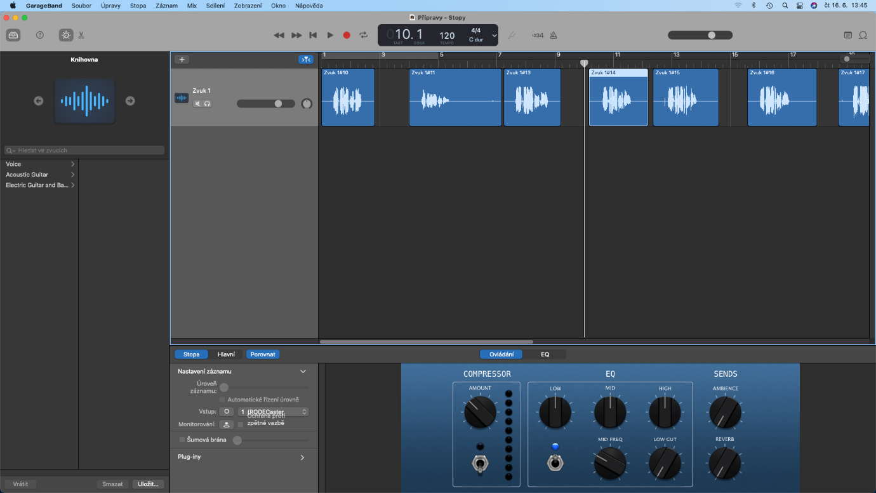
Picture 23 - Spoken Word in GarageBand

Insert sound into animation
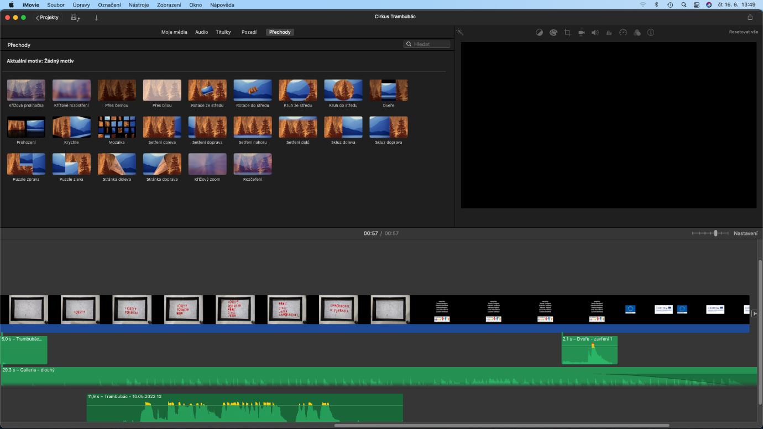
Picture 24 - iMovie – inserting recorded sound into animation
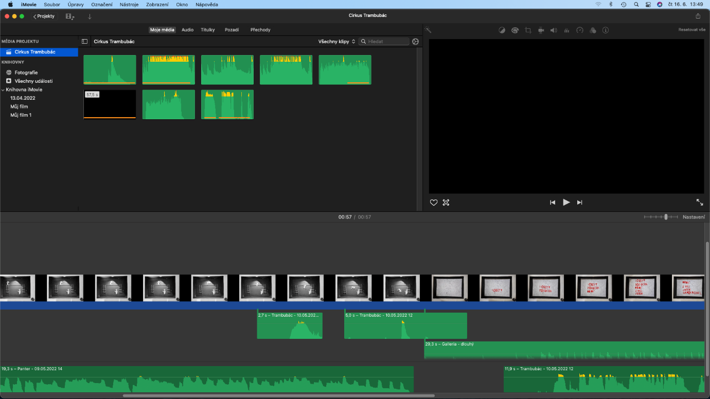
Picture 25 - inserting different sounds into an animation in iMovie

Project output
The output of the project is five short animated films created by sixth and seventh year elementary school students.
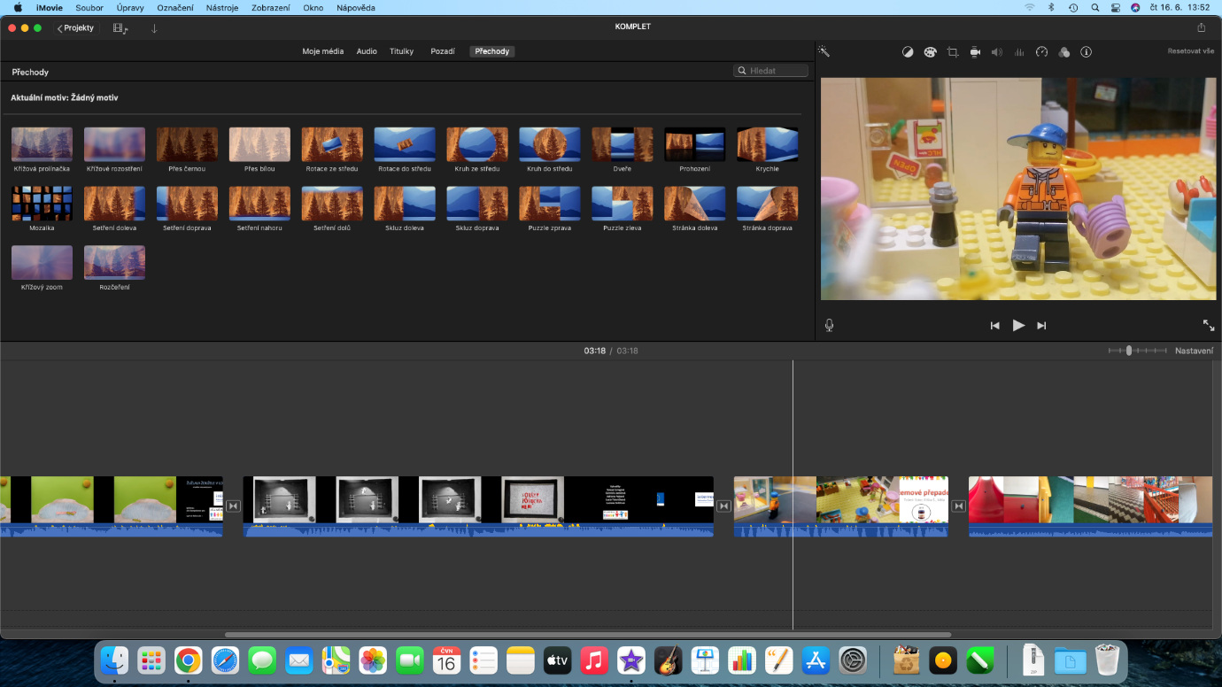
We then combined the five created animations, including the inserted sounds, into one integrated one that we have on our website. And also on the youtube channel, which we didn't use, we share this overall complete film via the link. https://youtu.be/FltvA8x4PYo

Preparation of a multimedia centre
We used an unused room in the basement without a window to equip the multimedia centre. It was necessary to paint the room, lay a new floor, and ensure ventilation. Subsequently, the room was soundproofed by a professional company.
Why was soundproofing needed? Sound is a longitudinal wave with a frequency from 16 Hz to 20 kHz. This wave causes an auditory sensation in the human ear, i.e. we hear him. The most common source of noise is oscillating bodies. This compresses and thins the air that surrounds it. As a result, longitudinal waves are created - sound that spreads through the air to the surroundings. Different sounds are produced according to the shape and size of the vibrating bodies.
Tones are sounds that are caused by periodic oscillations. They are created, for example, by musical instruments. Non-periodic oscillations tend to be unpleasant to the human ear and are called screeching, screeching, screeching, rattling, banging or, for example, noises. So it is noise.
Sound-producing bodies can be made to vibrate in different ways:
Impacts, strumming, shearing, permanent deformation and crushing of bodies, rapid movement of bodies, air flow between nearby flexible bodies, air flow around a sharp edge of a body, sudden change in pressure, ever-changing force.
The pitch of a tone is determined by its frequency. The higher the frequency, the higher the tone. Tone colour is determined by time course.
Sound propagation takes place in all substances. We most often hear sound that travels through the air. However, good spreading also occurs through liquids and flexible solids. The speed of sound depends on the magnitude of the forces acting between the molecules. Sound travels fastest in solids because these forces are greatest in them. Sound that bounces off large surfaces can be heard once more. This is an echo.
Sound reflections must be taken into account and dealt with in places where they are undesirable.
"Spaces that are to be used for communication between students and teachers, listening to music or other educational activities must meet the parameters of quality listening. Spatial acoustics is very important in this case and guarantees not only the intelligibility of the word, but also the perfect perception of sounds and tones when synchronised with the image.
The classroom in the Elementary School was intended as a small studio for teaching students and did not meet the space requirements of the Acoustics and reverberation times in space. After minor technical adjustments to outdated electrical wiring and lighting, the spatial acoustics in the room were solved with a suspended ceiling using Focus A mineral boards from the Ecophon company and a wall covering of foam broadband A50 boards from the Vicoustic company. After these modifications, the classroom became suitable for the required audio-visual teaching of pupils," said Miroslav Příhoda, head of the installation.
The preparation of the premises was financed from their own resources.
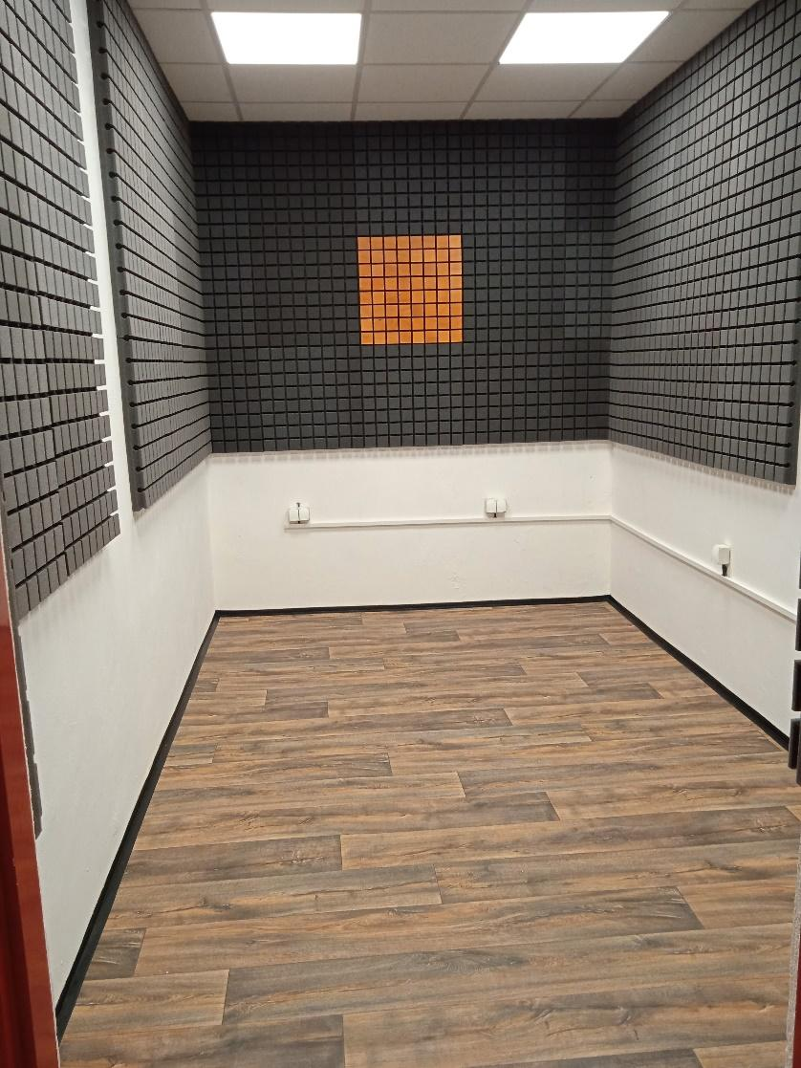
Picture 26 – Soundproofing the room
Subsequently, the premises were equipped with custom-made furniture. The option of a long table at the head of the room, a raised shelf for placing the monitor, and a table on the right side of the room where the keys will be placed was chosen. This layout will allow students sitting on stools to watch the animation process, recording and subsequent editing of the sound, inserting it into the created animation.
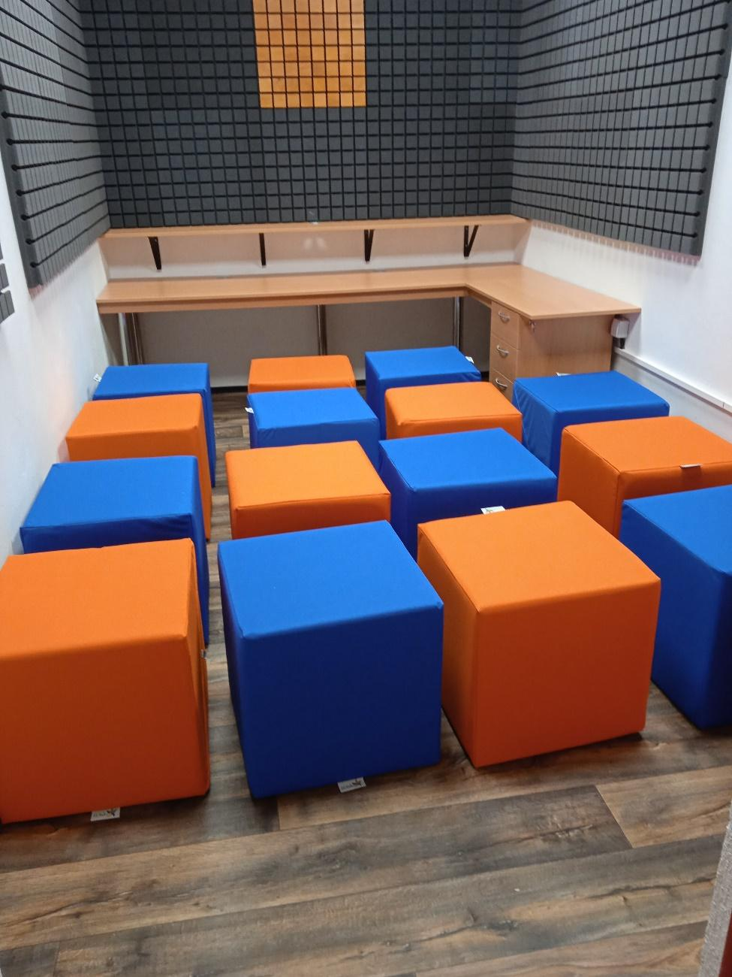
We supplemented the purchased equipment with headphone holders printed on a 3D printer.
Obrázek – Místnost i s na míru vyrobeným nábytkem, včetně sezení pro žáky

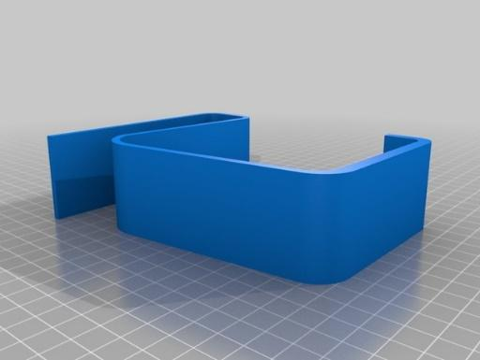
Printing on a 3D printer
- First introduction to the 3D printer, its connection, construction according to the instructions.
- Completion of the workshop, where students learned the main information about the history of the 3D printer, about the correct procedure for 3D printing, they were informed about errors and the possibilities of their elimination, repairs, correct settings of 3D printing, searching for suitable models on the Internet, creating their own 3D models.
- Getting to know the PrusaSlicer program, its correct settings.
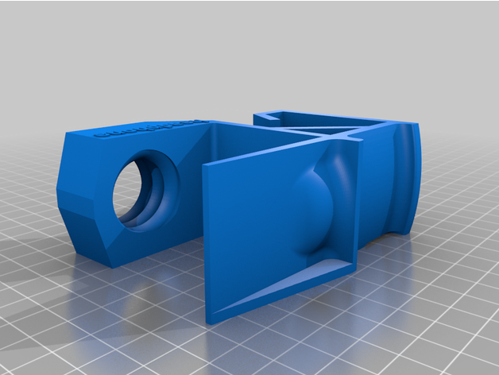
- Searching for the right model in the large shared database of Thingiverse.
- Downloading several models and testing them in PrusaSlicer, an idea of ​​the final appearance.
- The first selected model and also the printed one unfortunately did not fulfil the purpose, the model was too tall, the headphones were holding them, but they lay more on the work table, the holder was sliding.
- We went through various models of our choice, and finally chose one of them. It should be noted that it had many possible variants (so-called remixes), we chose the one where the cable could be tangled and the connector had a plug so that we would not have to look for it anywhere and it was always at hand. We could also choose the thickness of the shelf. A big advantage of this model is also the screw, thanks to which it is possible to mount this bracket really firmly. It does not twist in any way and holds even after handling the headphones.
- We set the height of the Quality layer to 0.20 mm, the filling then to 15 %, supports were not needed, we have PLA filament, printing one holder took approx. 7 hours complete.
- After testing in the multimedia studio, its placement and testing with headphones, we thought about the placement and also the colour differentiation of each of them.
- Printing of the remaining models and their subsequent installation in the multimedia centre.
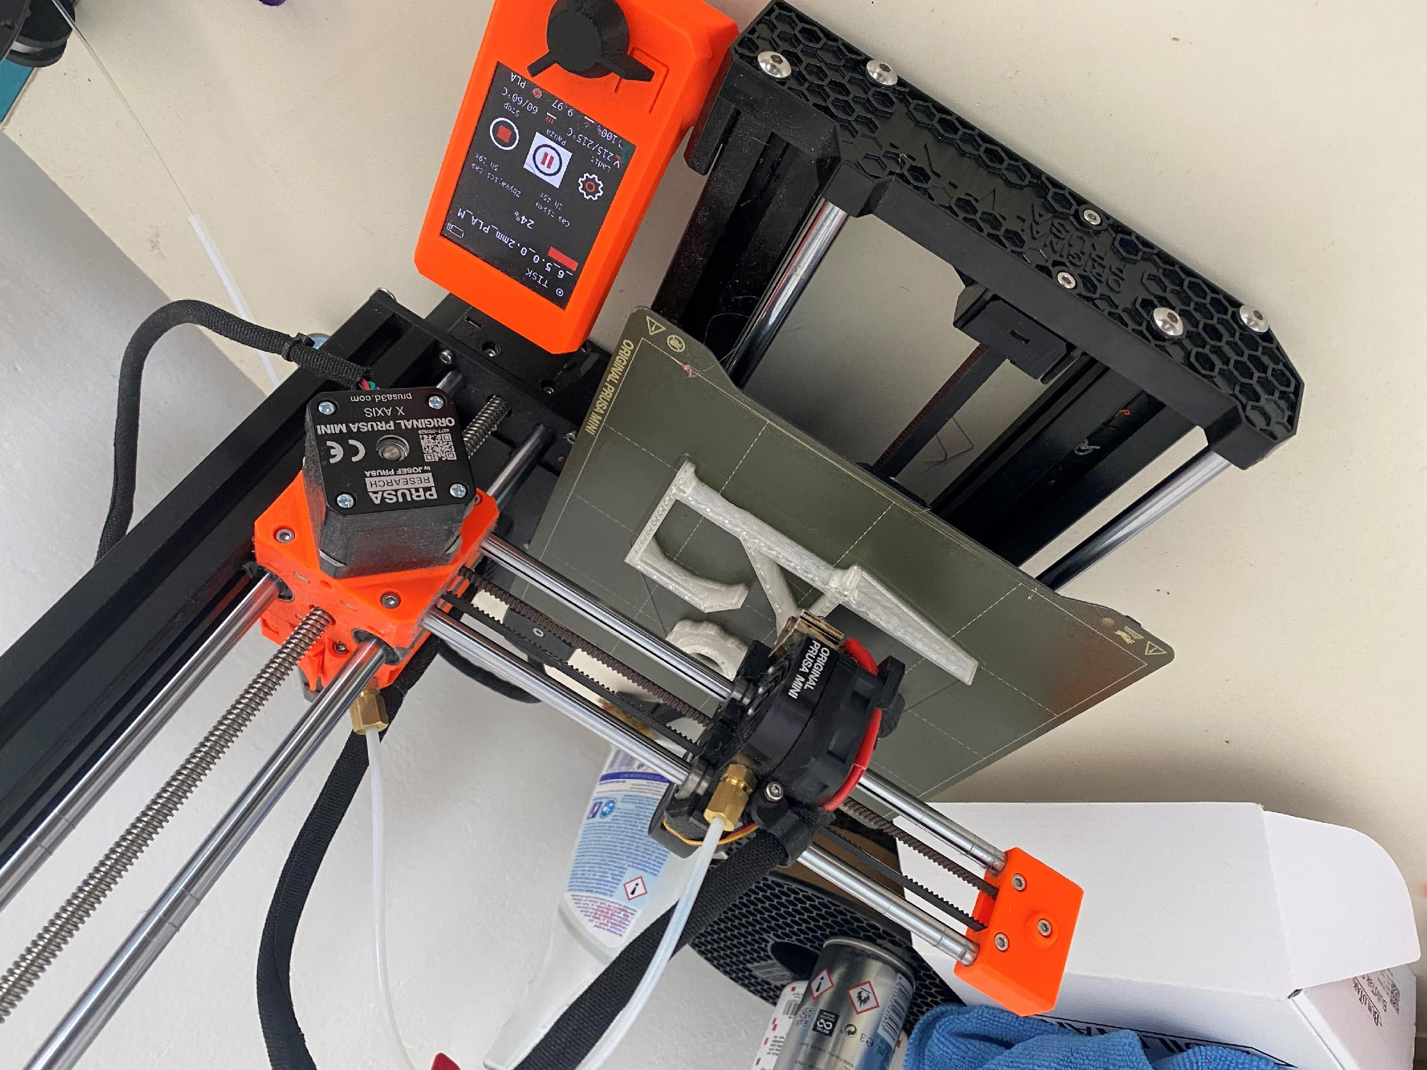
Picture 30 – 3D printer printing our model
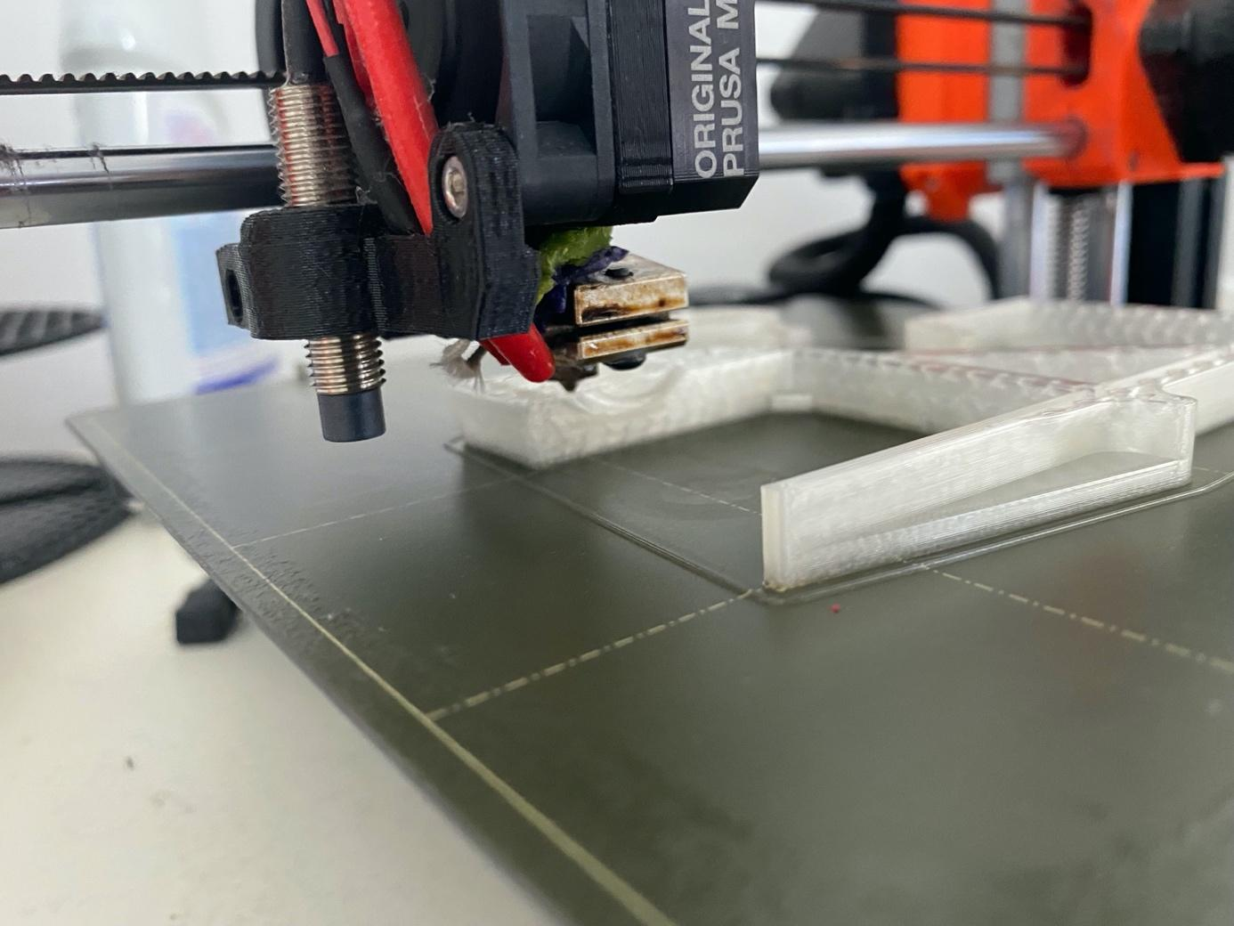
Picture 31 – 3D printing in detail
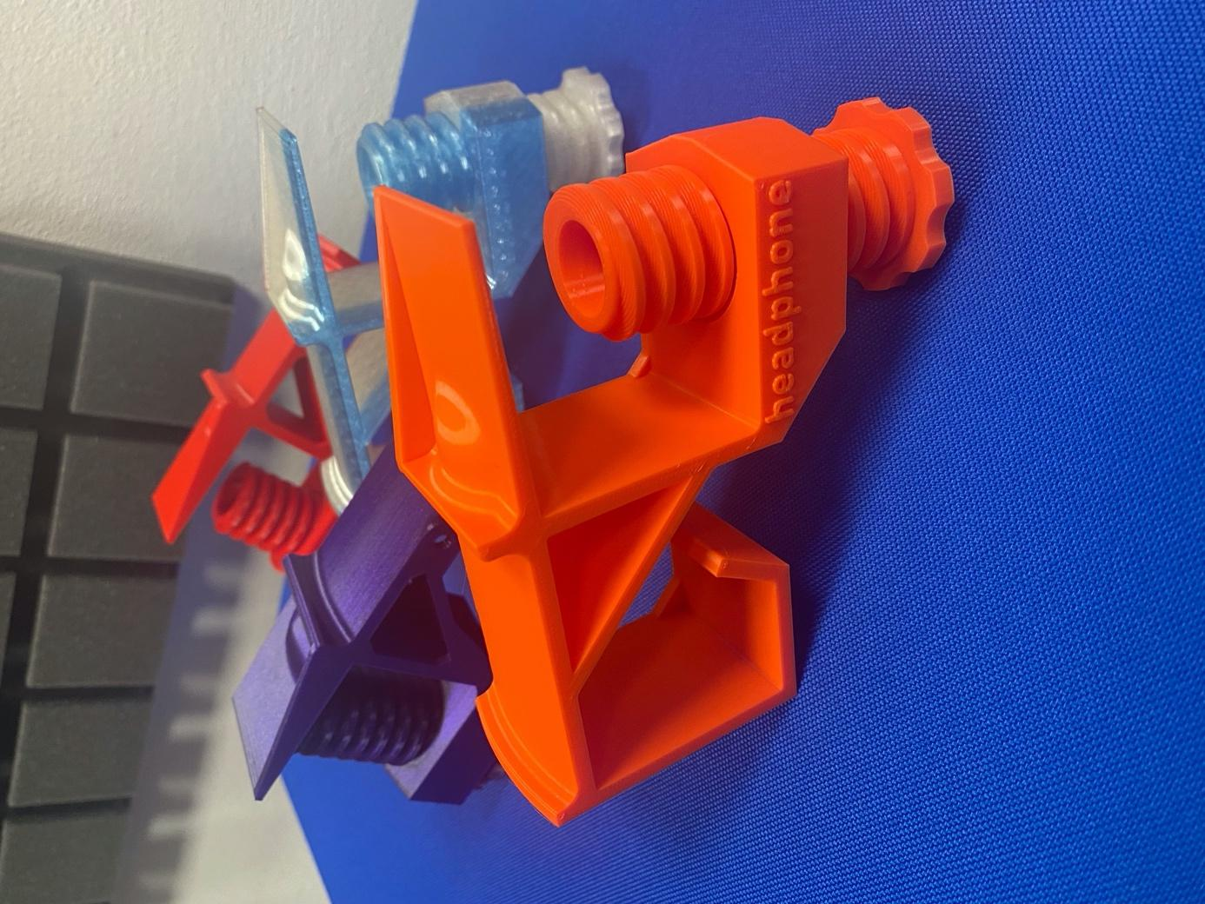
Picture 32 – Headphone holder for multimedia studio
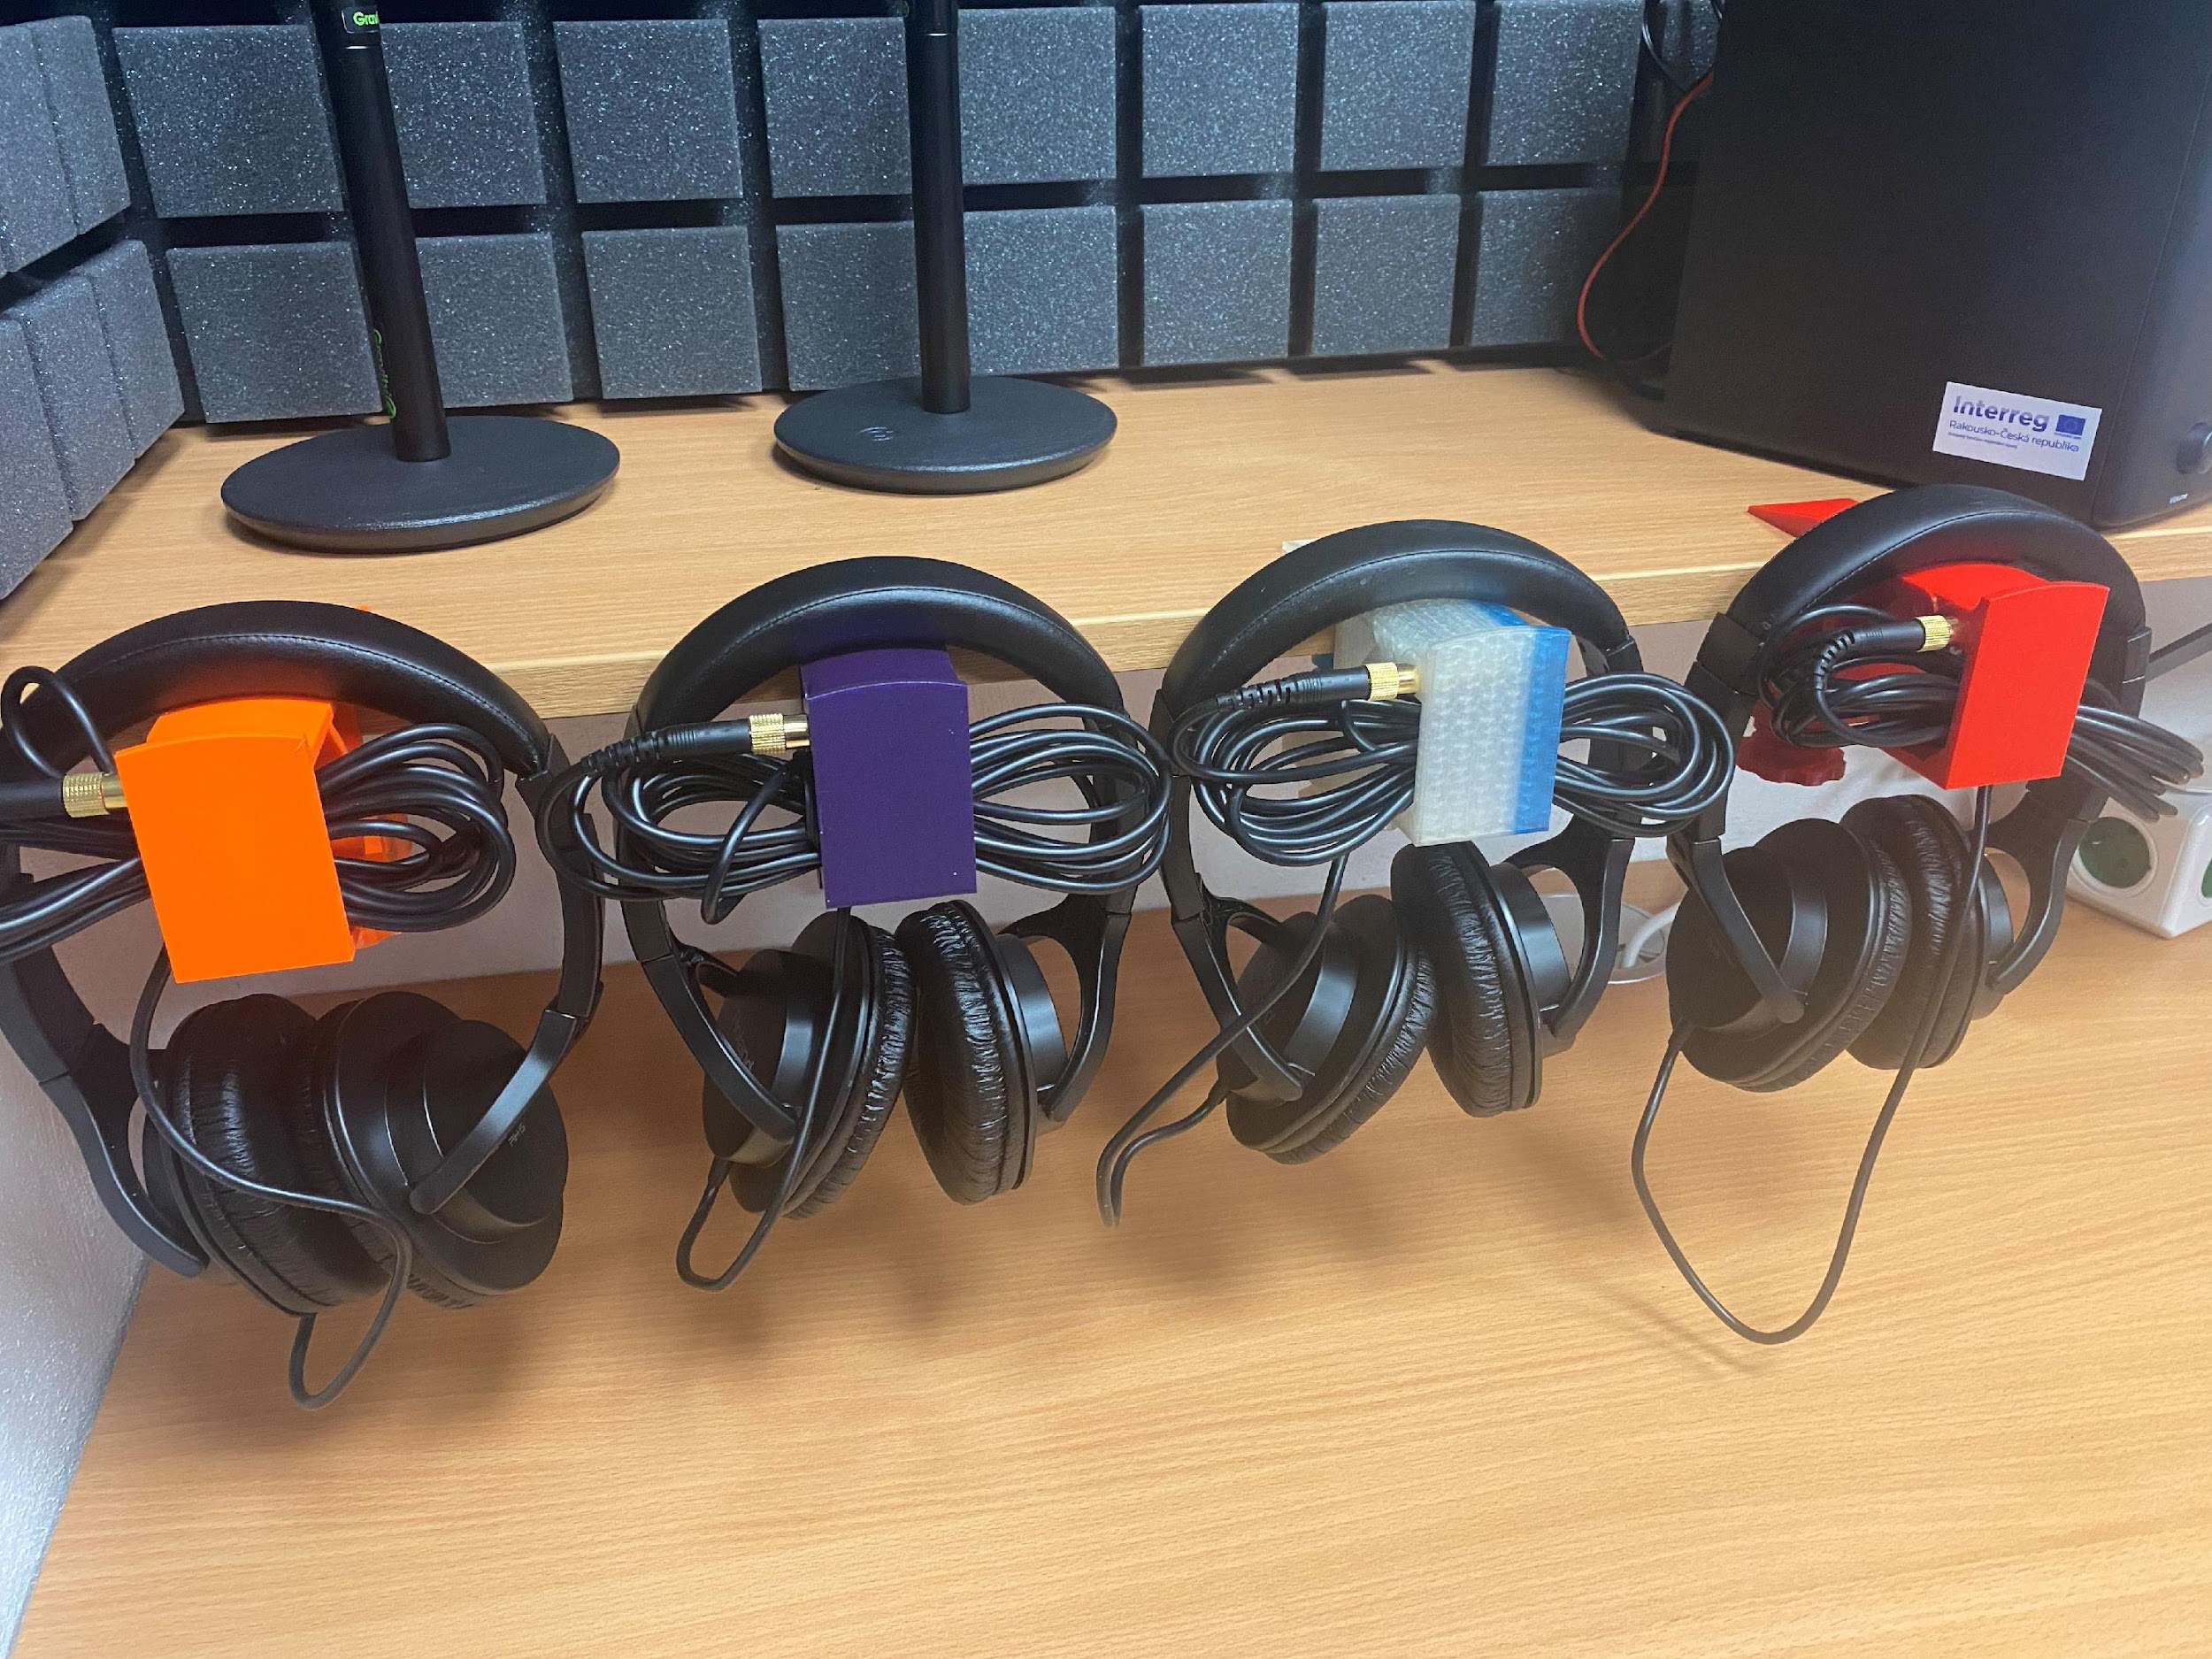
Picture 33 – Use in a multimedia studio

Financial complexity of the project
Table 1 - Multimedia centre equipment
Equipment | Number of pcs | Price
Camera stabiliser (gimbal) Zhiyun Weebill-S | 1 | 8 648,00 CZK
Video led panel Viltrox VL-D640T (set 2x light, 2x tripod + bag) | 1 | 6 550,00 CZK
Nikon Z50 digital camera | 1 | 28 538,00 CZK
LG monitor 24 LG LED | 1 | 3 735,84 CZK
Studio monitor with speaker, Presonus Eris E4.5 BT | 1 | 5 250,00 CZK
Recording studio for creating podcasts - RodeCaster Pro | 1 | 13 194,00 CZK
PC mini Apple Mac mini M1, 8GB, 256GB | 1 | 20 678,00 CZK
Wireless keyboard, Apple Magic Keyboard | 1 | 2 772,84 CZK
Vocal microphone, Audix F50 | 4 | 1 270,00 CZK
LG monitor 24MP60G 24 | 1 | 2 900,00 CZK
ROLAND RH-5 - instrument headphones | 4
Gravity MS T 01 B AH Stands (Adam Hall) | 4
Gravity MA GOOSE M, microphone attachment, goose, AH Stands | 4
93 536,68 Kč
Table 2 - Equipment and modifications of the multimedia centre
Device | Price
8 pcs bean bag blue | 12 904,00 CZK
8 pcs bean bag orange | 12 904,00 CZK
atypical furniture-table | 9 222,88 CZK
furniture-shelf | 5 471,88 CZK
furniture-container | 8 375,88 CZK
PVC | 6 334,00 CZK
PVC laying | 7 268,00 CZK
cables to the recording centre | 2 958,00 CZK
cables to the recording centre | 2 286,00 CZK
acoustics, electrical installation, fan, revision | 163 297,50 CZK
total costs (paid from own resources) | 231 022,14 CZK

Our equipment
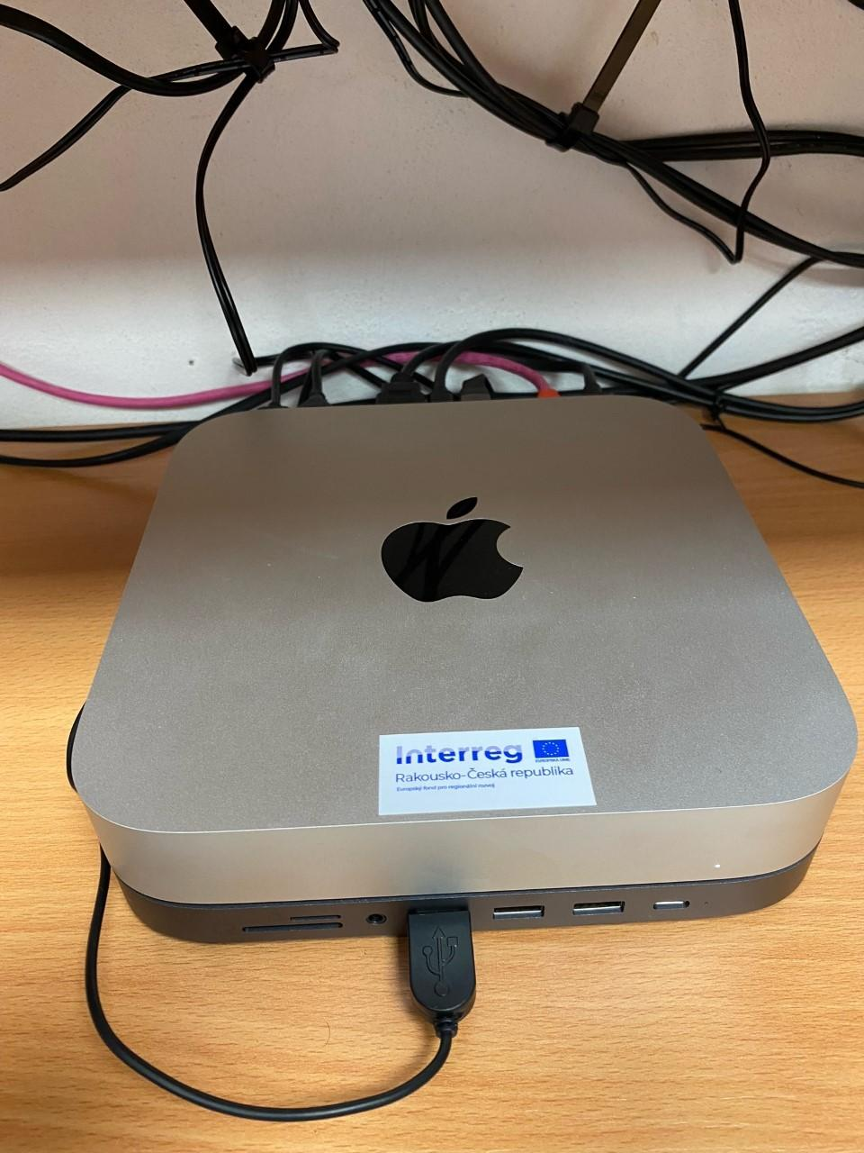
Picture 34 – Mac mini M1
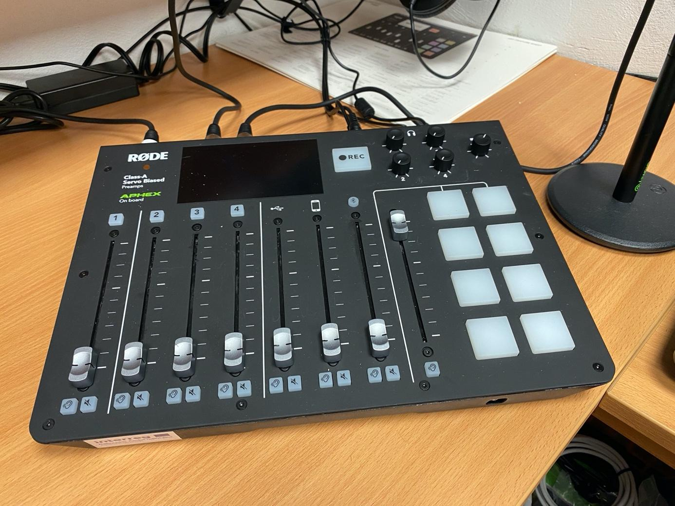
Picture 35 – RodeCaster PRO

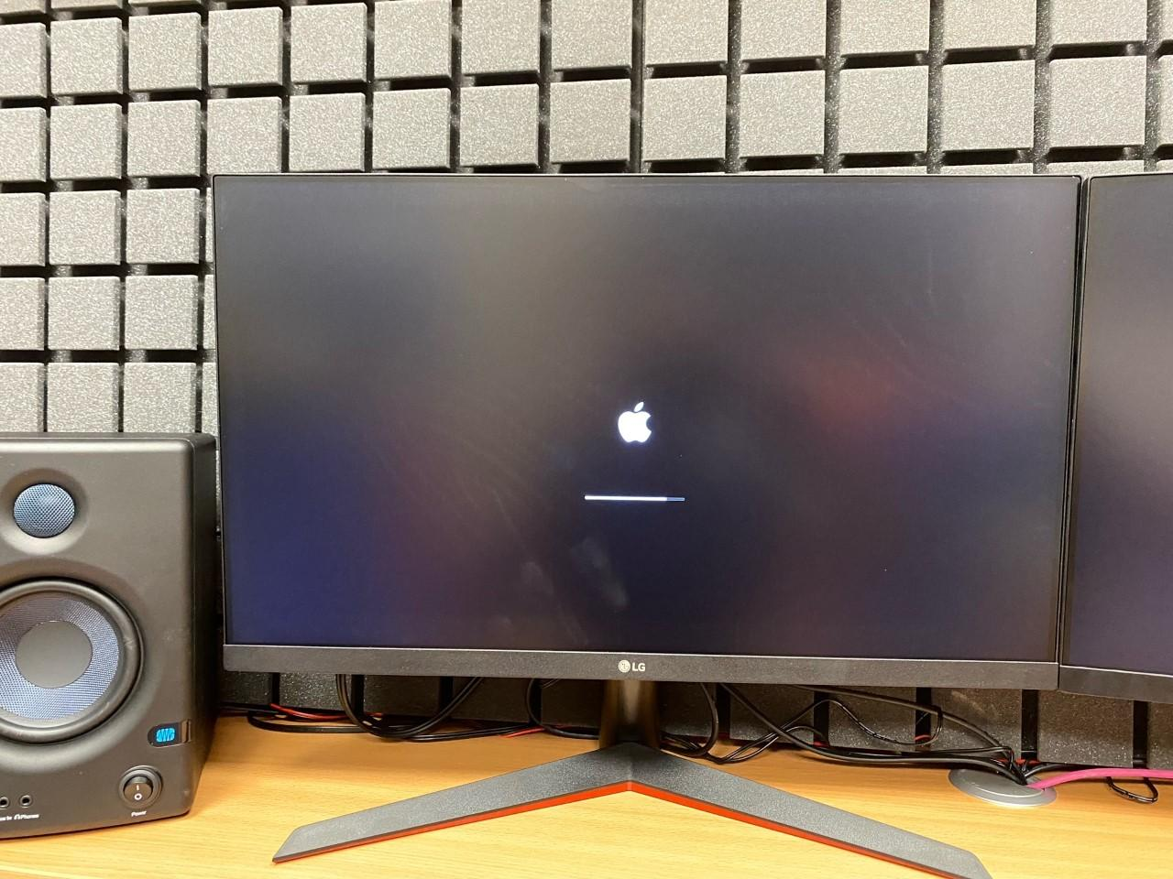
Picture 36 – LG monitor 24‘‘

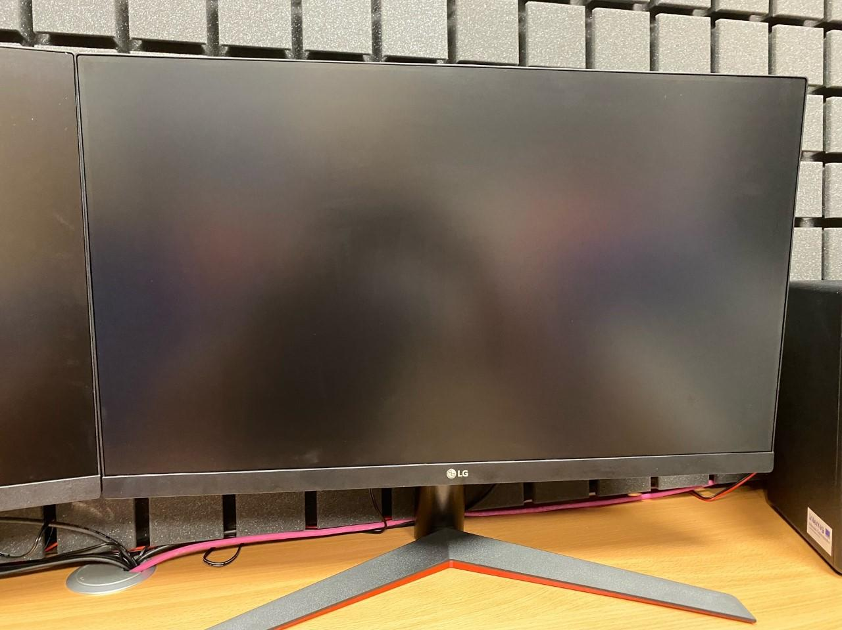
Picture 37 – Monitor LG

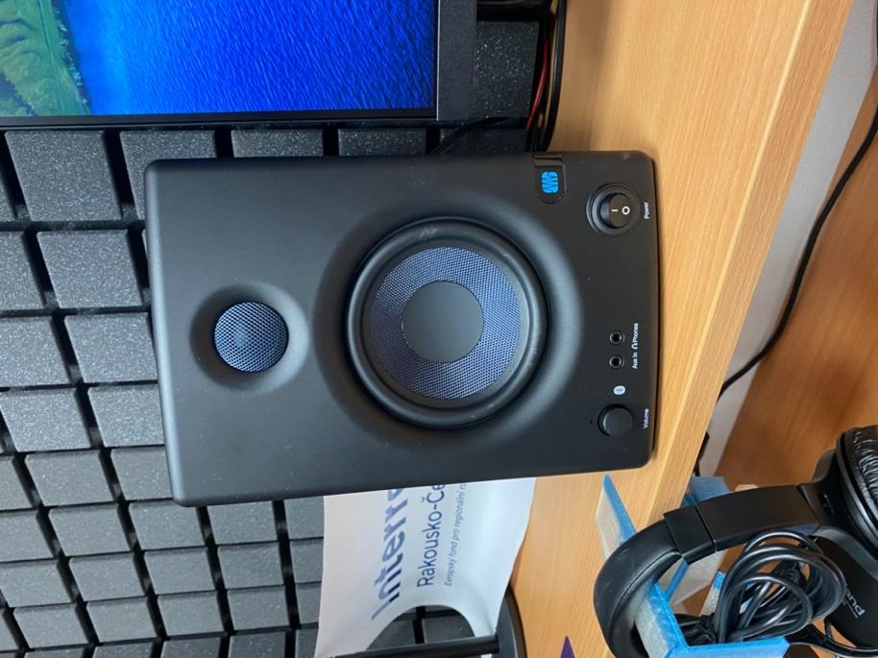
Picture 38 - Presonus Eris E4.5 BT
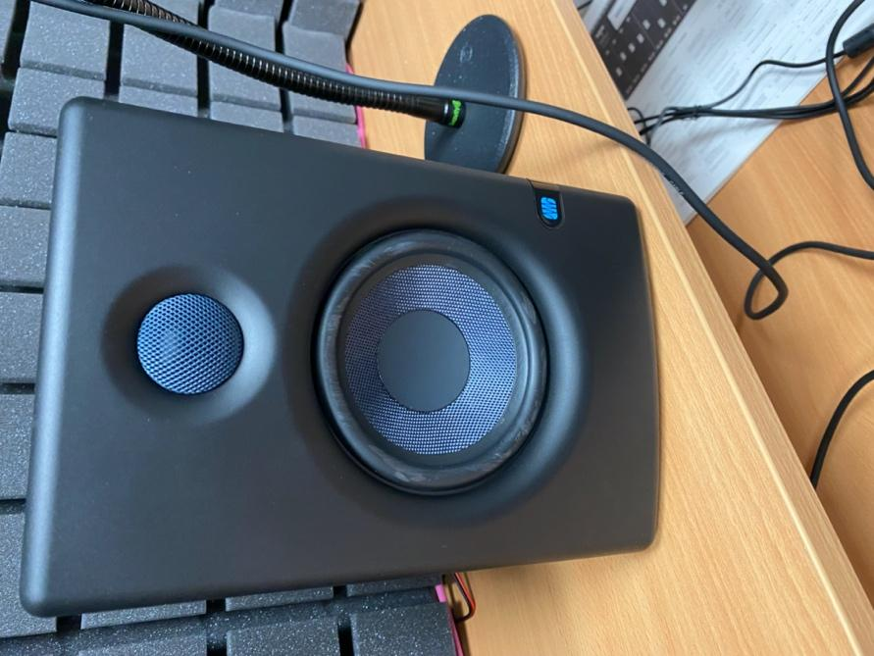
Picture 39 – Presonus Eris E4.5 BT studio speakers
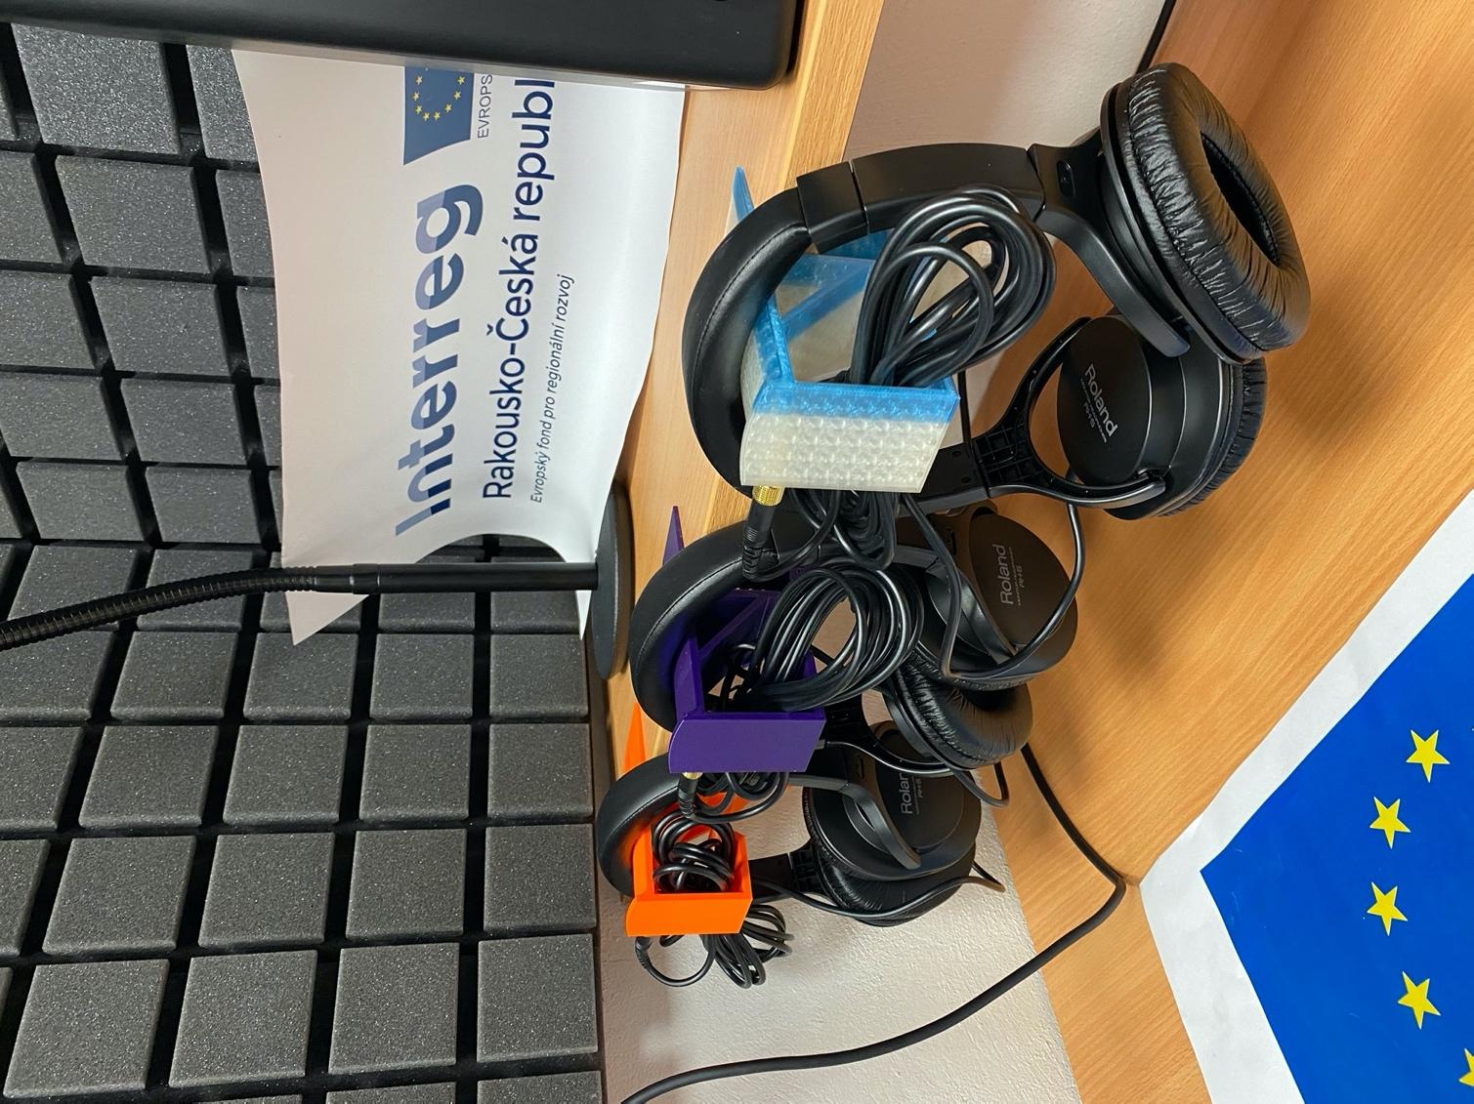
Picture 40 – ROLAND RH-5 studio headphones
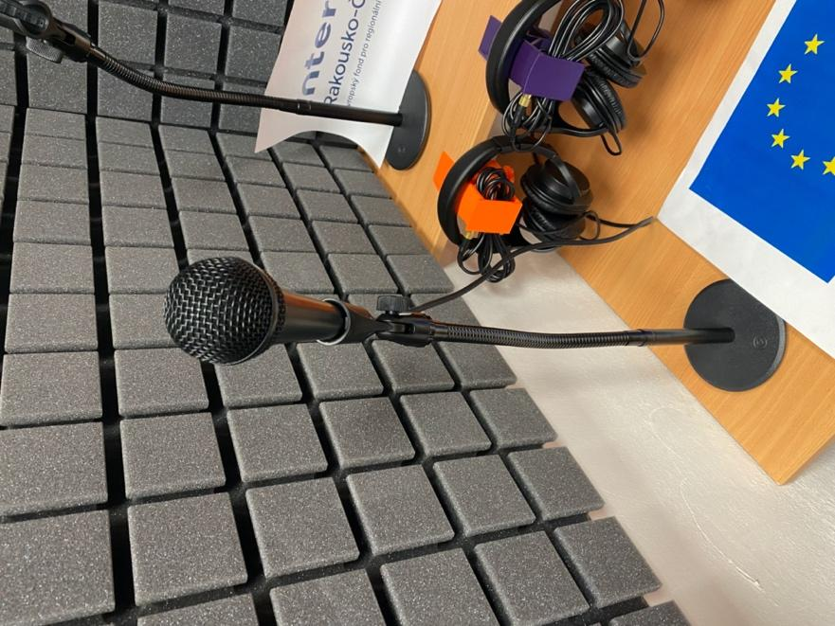  Picture 41 – Vocal microphone, Audix F50 | 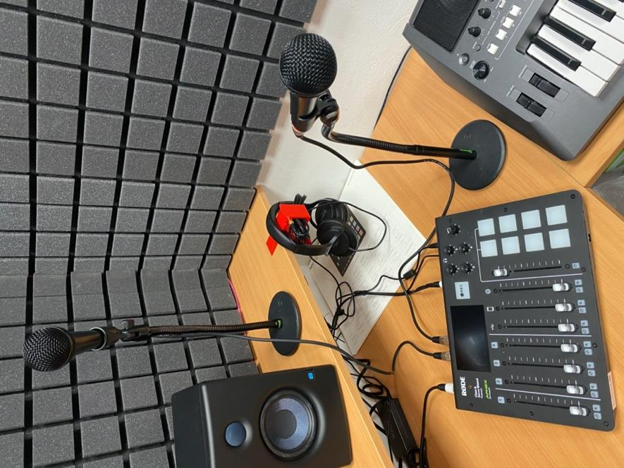  Picture 42 - Audix F50 microphone including Gravity stands
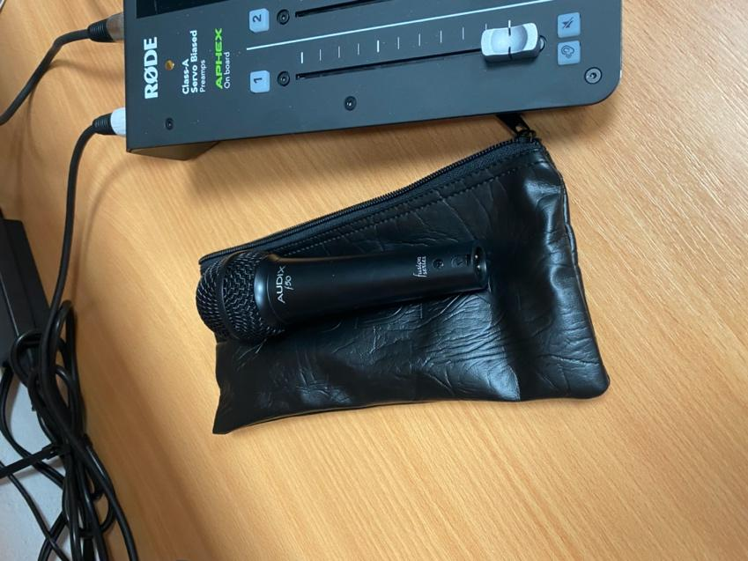
Picture 43 – Vonyx F50
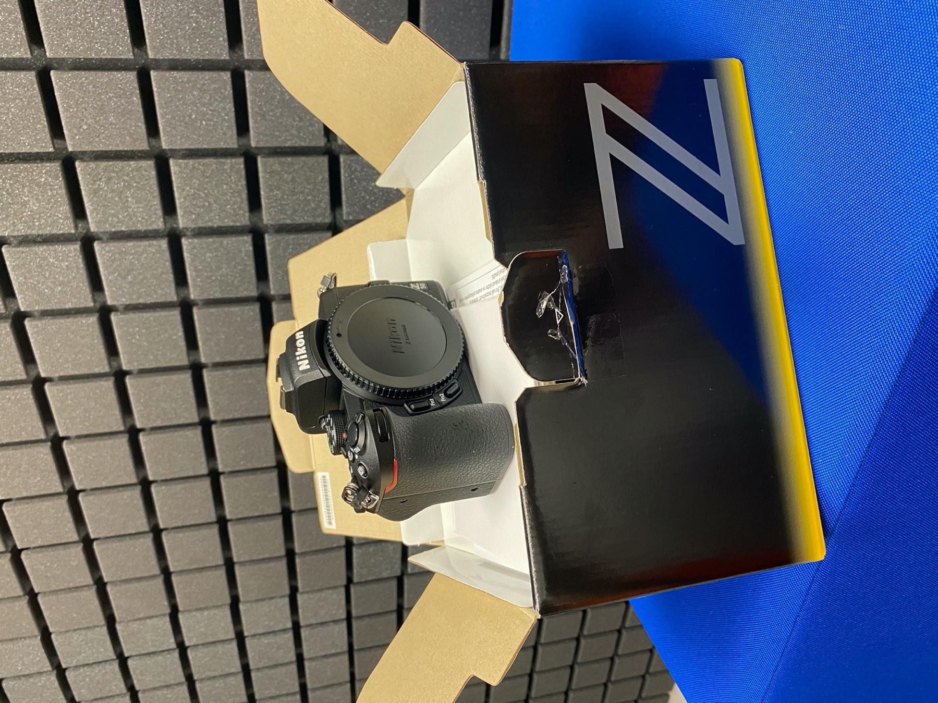
Picture 44 – Nikon Z50 camera
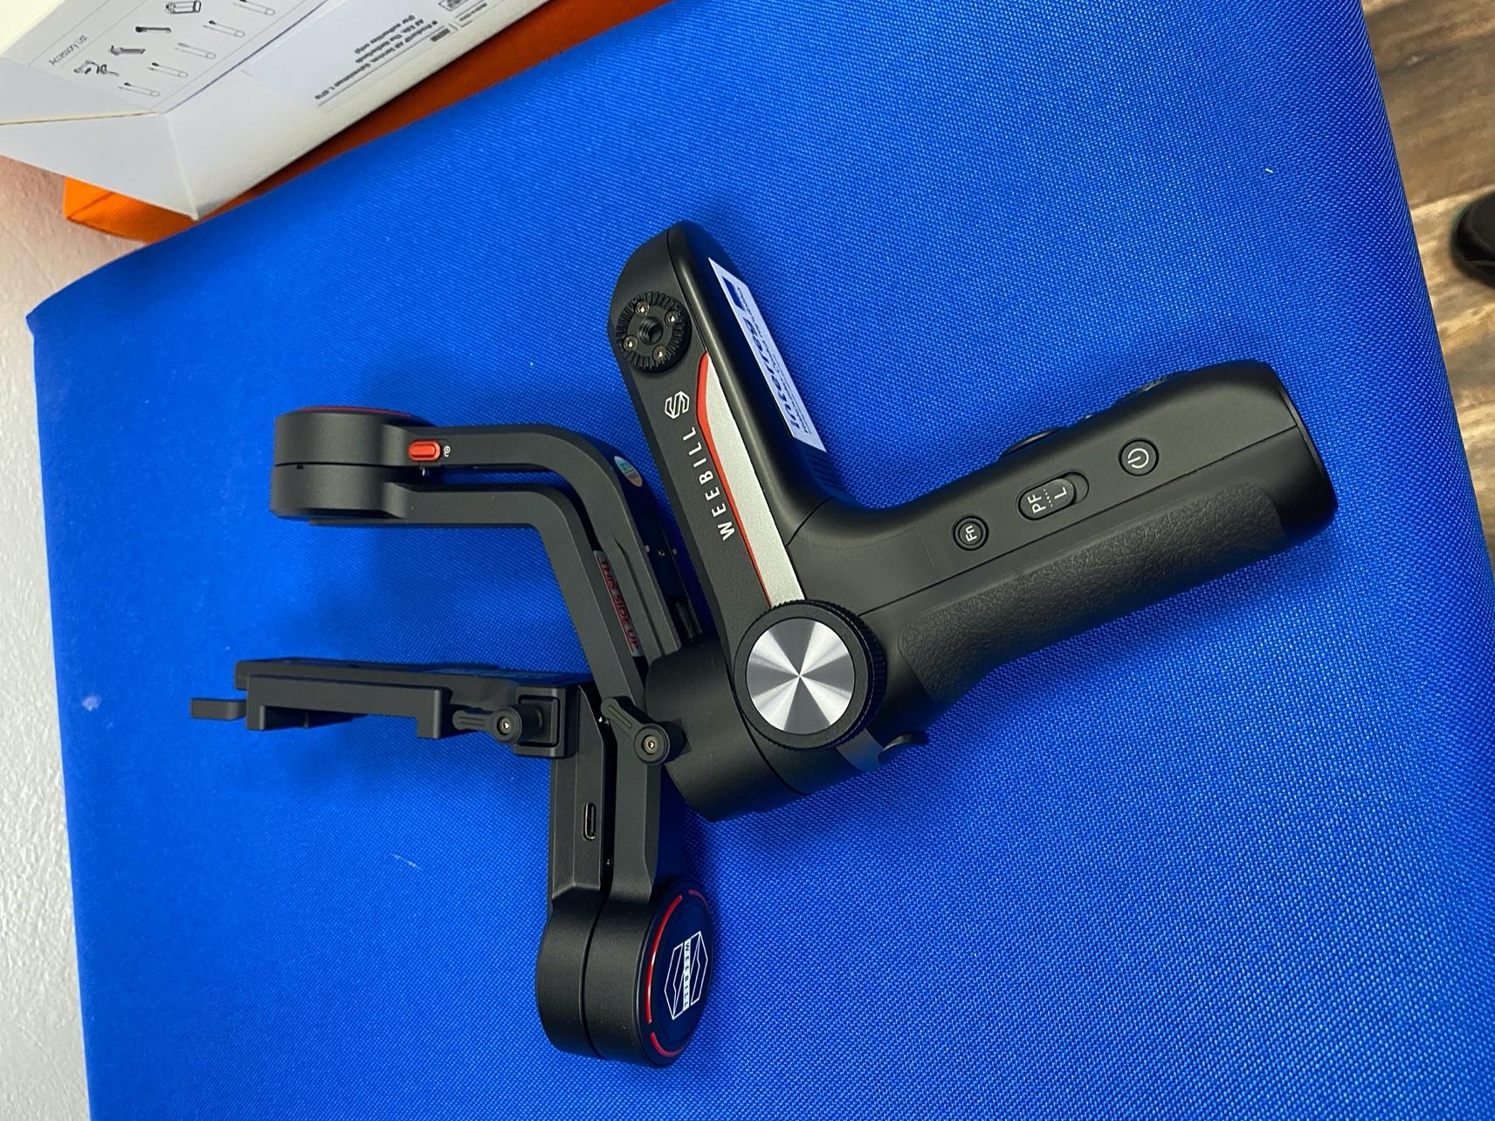
Picture 45 - Zhiyun Weebill-S

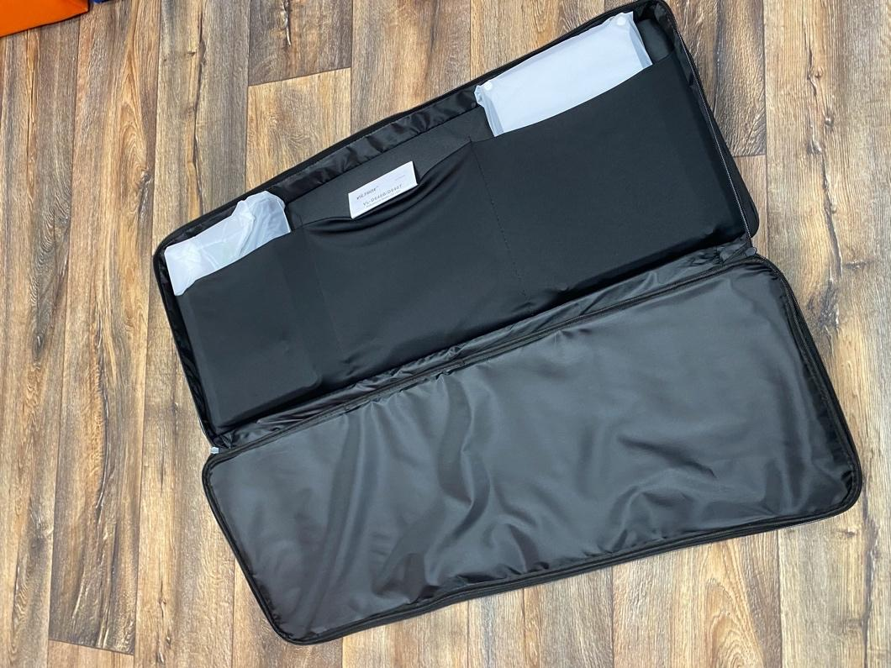
Picture 46 - Video led panel Viltrox VL-D640T

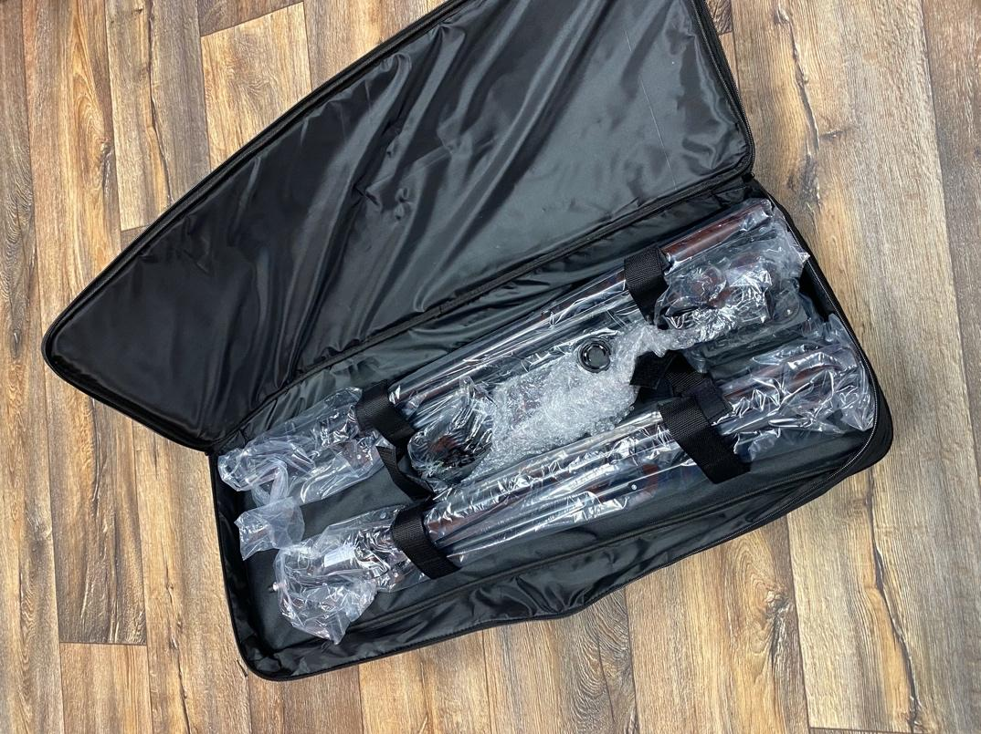
Picture 47 – For better scene lighting Viltrox VL-D640T

Evaluation of the project
The DigiMe project helped us improve the digital skills of pupils and teachers. With the financial support of the Interreg V-A program Austria – Czech Republic (ATCZ 216), we created a number of animations and learned to work in a new recording studio. Our students improved their presentation skills in the school competition. Thanks to the exchange with the Austrian school MIM Wendstattgasse, our pupils gained many new friendships. Although the visit to Vienna was an imaginary point behind the DigiMe project, we look forward to drawing on the newly acquired experience, skills and new friendships in the years to come.

Picture list
Picture 1 – Heavyweights running on Greek amphora 6
Picture 2 – Laterna magica 6
Picture 3 – Lumiere brothers - arrival of train ratři Lumierové - příjezd vlaku 7
Picture 4 – Zoetrope made by pupils 8
Picture 5 – Template for making a zoetrope 8
Picture 6 – Stills from the animated short Knot on a Handkerchief (1958) 9
Picture 7 – Storyboard 10
Picture 8 - Production of background and props 11
Picture 9 – Production of background and props 12
Picture 10 - Production of background and prop 12
Picture 11 - Lighting 12
Picture 12 – Photograph of movement 12
Picture 13 – Creating a photo album in PowerPoint 13
Picture 14 - Timing 13
Picture 15 - Export do mp4 14
Picture 16 – Editing animations 14
Picture 17 – Post-production 16
Picture 18 - macOS, an operating system from Apple 16
Picture 19 - GarageBand 17
Picture 20 - iMovie (editing, editing, video editing) 17
Picture 21 - GarageBand environment when recording piano sound 18
Picture 22 –Recording different types of sound into animation (spoken word, falling, noise)19
Picture 23 - Spoken Word in GarageBand 19
Picture 24 - iMovie - inserting recorded sound into animation 20
Picture 25 - inserting various sounds into an animation in iMovie 20
Picture 26 – Soundproofing the room 23
Picture 27 – Room with custom-made furniture, including seating for pupils 25
Picture 28 - First model (failed functionality) 26
Picture 29 - A model that met our requirements 26
Picture 30 – 3D printer printing our mode 26
Picture 31 – 3D printing in detail 27
Picture 32 – Headphone holder for multimedia studio 28
Picture 33 –Use in a multimedia studio 29
Picture 34 – Mac mini M1 32
Picture 35 – RodeCaster PRO 33
Picture 36 – LG monitor 24‘‘ 34
Picture 37 – Monitor LG 34
Picture 38 - Presonus Eris E4.5 BT 35
Picture 39 – Presonus Eris E4.5 BT 35 studio speakers 35
Picture 40 – ROLAND RH-5 36 studio headphones 36
Picture 41 – Vocal microphone, Audix F50 37 37
Picture 42 - Audix F50 microphone including Gravity stands 37 37
Picture 43 – Vonyx F50 37
Picture 44 – Nikon Z50 camera 38
Picture 45 - Zhiyun Weebill-S 39
Picture 46 - Video led panel Viltrox VL-D640T 40
Picture 47 – For better scene lighting Viltrox VL-D640T 40 40

List of tables
Table 1 - Equipment of the multimedia centre 30
Table 2 - Equipment and modifications of the multimedia centre 31

https://www.csfd.cz/film/158481-uzel-na-kapesniku/galerie/

